# Data

## Definition:

Data is the collection of information.

## Importance:

Data is important because it provides insights for analysis and help us to make better business decisions.

## Types of Data:

Following are the 4 types of data

### Nominal: Data with name or label. Data with no-inherent order or ranking. Such as Gender, Pepsi, Coke, Vinay …..

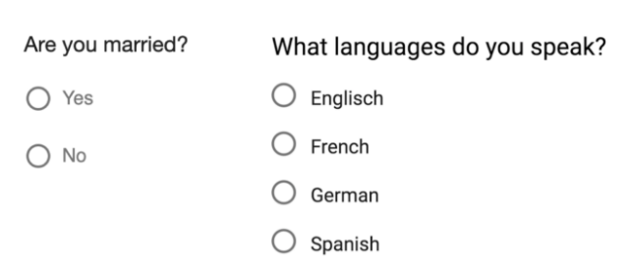

### Ordinal: Data with rank or order series such as Good, Average, Below Average and Bad



### Discrete: Anything that you can express in number. It holds finite number of possible values. It is the whole(integer) number

Eg: Number of students in class. Number of people in the house.

### Continuous: Possible numeric values It holds infinite number of possible values. That means in a scale between 1 to 2, we have infinite possible values between 1 and 2. It can be 1.2, 1.34, 1.4578, 1.9876543 and so on

Eg: Weight of the person can be 50.2kg or 62kg or 58.002kg and so on. Height of the person

# Statistics

## Definition:

Statistics is not only the analyzing the data, which also includes data collection, interpretation and presentation with the help of mathematical computations.

## Need of Statistics:

When we have the problems, we can’t guess the solution and blindly say it will work. By using statistical techniques, we can provide the proven solution which everybody can understand easily.

Statistics can be used to derive meaningful insights from data by performing mathematical computations on it.

In Statistics, we have several statistical functions, principles and algorithms which can be implemented to analyze raw data, build a Statistical Model and predict the result.

## Population:

Total available data for the given problem. For example, need to find the average height in the given state? Here all the people height in the state is population. It is very difficult to go each person and ask the height. It is very difficult to find the height of all the people in the given state.

## Sample:

Collect few records randomly from the population is called Sample. Sample is the subset of population. In the above problem, instated of collecting all the person height, we collect few persons height randomly that is called sample.

Ex: Exit poll election results for the party is going to win.

## Sample Techniques:

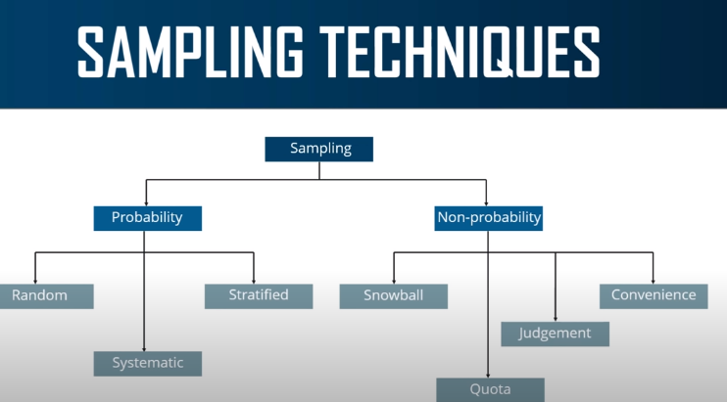

Sampling Techniques are 2 types

### Probability Sampling: It is a sampling technique in which samples from large populations are chosen by using theory of probability (chance of getting selected)

#### Random Sampling: Each member of the population has equal chance of being selected in the sample. That means randomly go and select individual.

#### Systematic Sampling: Every nth record is chosen from the population to be a part of the sample

#### Stratified Sampling*:* By using common characteristics divide population into groups(subsets). After grouping, apply random sampling on these groups to generate the sample data.

### Non-probability Sampling:Non-probability sampling is defined as a sampling technique in which the researcher selects samples based on the subjective judgment of the researcher rather than random selection. It is a less stringent method. This sampling method depends heavily on the expertise of the researchers.

### Non-probability sampling is a sampling method in which not all members of the population have an equal chance of participating in the study, unlike probability sampling. Each member of the population has a known chance of being selected. Non-probability sampling is most useful for exploratory studies like a pilot survey (deploying a survey to a smaller sample compared to pre-determined sample size). Researchers use this method in studies where it is impossible to draw random probability sampling due to time or cost considerations.

## Types of Statistics: In Statistics we have 2 types

### Descriptive Statistics: Descriptive Statistics makes use of Numerical methods and Visualization techniques to summarize the sample data. As we are summarizing the data in one group(sample), there is no uncertainty because you are describing only the people or items that you measure.

### Inferential Statistics: When you want to draw inferences, conclusions, estimate or generalize statement about the population data based on the sample data, then will go for Inferential Statistics.

## Descriptive Statistics: Numerical Methods

### Measures of central tendency: Describes the central position of a frequency distribution for a group of data.

#### Mean: Mean is average of the dataset.

* Population:

$μ$ = $\frac{\sum_{i=1}^{n}{{ x}_{i}}}{N}$

* Sample:

$\overline{x}$ = $\frac{\sum_{i=1}^{n}{{ x}_{i}}}{n}$

* Disadvantage of Mean is Outliers. If we have outliers, then go to Median or remove the outliers and calculate the Mean

#### Median: Median is middle number after sorting the dataset.

* If the number of records is Odd number, consider middle number as Median
* If the number of records is Even number, consider average of 2 middle numbers as Median

#### Mode: Mode is most occurrence values

* Bi model Mode: If 2 numbers of occurring high frequency as same number of times
* Multi model Mode: If more than 2 numbers occurring high frequency as same number of times

### Measures of spread:

### How far out from the center, does the data extend? You can use the range or standard deviation to measure the dispersion. A low dispersion indicates that the data points are more tightly around the center. Higher dispersion signifies that data points fall further away from the center.

#### Variance: square of difference between Mean with all data points

$σ^{2}$ = $\frac{\sum{({ x}_{i}- \overline{x})}}{N}$

$s^{2}$ = $\frac{\sum{({ x}_{i}- \overline{x})}}{n-1}$

#### Standard Deviation: square root of Variance.

$σ$ = $\sqrt{Variance}$ or $\sqrt{σ^{2}}$

S = $\sqrt{Variance}$ or $\sqrt{s^{2}}$

#### Range: Maximum number – Minimum number of the data set

#### Skewness: This measure tells us whether the distribution of the data points is symmetric or skewed. Skewness gives us information about whether the data points are closed to center or spread across (tailed).

#### If the right tailed skewness means, most of the data distribution is in left side and it is positive skewed.

#### If the left tailed skewness means, most of the data distribution is in right side and it is negative skewed

#### Skewness of the normal distribution is zero.

#### Kurtosis: It gives us the information as how peak your distribution is?

#### If it is high peak means all the data points are very close to each other.

#### If it is flattened means all the data points are spread across

## Descriptive Statistics Visualization Techniques:

Bar Chart: Simple representation of graphical manner which contains Number of occurrences of each data point.

Histogram: It contains the number of occurrences of range of data points. It creates range/buckets. It is used to know the distribution of dataset.

Box Plot: The main purpose is to find the outliers of data.

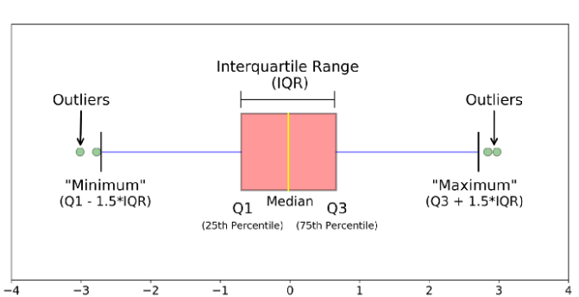

* **Median (Q2/50th Percentile):** the middle value of the dataset.
* **First quartile (Q1/25th Percentile):** the middle number between the smallest number (not the “minimum”) and the median of the dataset.
* **Third quartile (Q3/75th Percentile):** the middle value between the median and the highest value (not the “maximum”) of the dataset.
* **Interquartile range (IQR):** 25th to the 75th percentile.
* **Whiskers (shown in blue):**
* **“maximum”:** Q3 + 1.5*IQR
* **“minimum”:** Q1 -1.5*IQR
* **Outliers:** (shown as green circles)
* We will get the outliers for a single feature(column) not entire row.
* Data point is nothing but one row in the dataset

# Random Variable:

Random variable is nothing but if an event (tossing coin, rolling dices) takes multiple values, its associate likelihood or chance of each of that value to occur. A variable remains random unit it occurred. If it occurs, we know the outcome and no more random.

Random variable should take more than one value and each value of the variable there should be associate probability (equal chance to occur for all the values). All the futuristic events are random variables except universal truths.

An event which will take more than 1 value is variable and each of the value there is associated chance to occur is random variable.

Opposite to variable is called Constance

Example whether it rains today in Hyderabad or not? As possibilities of outcome is Yes and No. there is the possibility to occur of either of the value.

Tossing the coin landing with Heads. Outcome of the value stores as Random Variable

Random variables are divided into 2 types:

## Discrete Random Variable:

Random variable that can assume a countable number of values. Random variable that takes finite number of values.

A Random Variable construct on Discrete variable is called Discrete Random Variable.

EX: number of defect light bulbs in the box. Number of children in the family.

## Continuous Random Variable:

Random variable that can assume any quantity (value) that can assume all possible values on numerical scale. These are infinite numbers.

Ex: time it takes to complete the race? It can be 3 min or 5 min or 3.2 min……

# Z Score:

Z Scores are important when we are normalizing the data sets before building the Machine Learning Algorithms and can be used in Hypothesis testing as well. Z Scores makes use of Mean and Standard Deviation of the data set to specify the relative location of a measurements.

Steps to compute the Z score:

* First compute the Mean of the Data set
* Compute the Standard Deviation of the data set
* Subtract Mean from each individual value in the data set then divide with Standard Deviation
* These values called Z Score values
* It denotes as distance between the given data point to the mean in standard deviation terms. This is basically used to normalizing the data set.
* When we apply Z Scores most of the times values between -3 to +3

# Probability (P(X)):

Probability is a branch of mathematics that deals with the occurrence of a random event.

# Probability Distribution

**Distribution** is nothing but framework or set of rules. Any data follows those set of rules defined by a distribution, then call that data follows distribution.

Probability Distribution has 2 types.

## Discrete Probability Distribution: Probabilities associated with discrete variables is called discrete probability distribution. It can be expressed in terms of graph or table. Example is Binomial Distribution

### Binomial Distribution: Binomial distribution has its own rules, any data satisfies these rules, we can call that dataset follows Binomial distribution.

Following are the set of rules:

* The experiment should consist of “n” repeated trials (more than 2 times). That means it can 100 time, 50 times… finite number of times.
* Each trial can result in just two possible outcomes.
* The Probability of Success, denoted by P, is the same on every trail. That means always P(success = 0.5)
* The trails are independent; that is, the outcome on one trail does not affect the outcome on others trail.

**Examples:** Tossing a coin then what is the probability of landing Head. P(X=Head) =0 or P(X=Head)=1. Here 0 or 1 is the Binomial distribution value.

What is the probability of passing the exam? P(X=Pass)=0 or P(X=Pass)=1

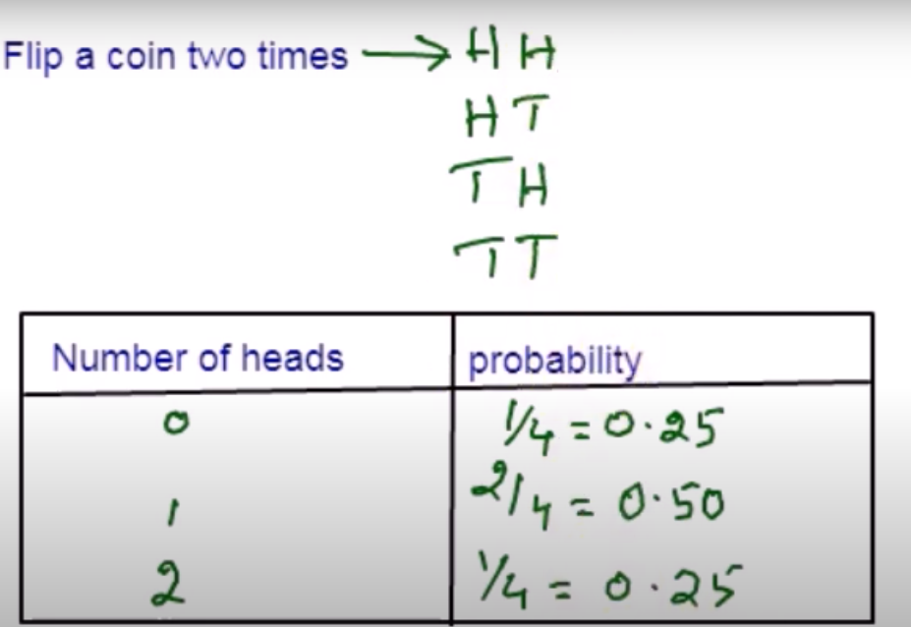

Probability is not for single time/event, occurs for many repetitions/longer run.

## Continuous Probability Distribution:

Probabilities associated with continuous variables is called continuous probability distribution. Example is Normal Distribution

### Normal Distribution:

Following are the rules/properties of Normal Distribution

* Data points falls in bell shared curve.
* Shape will be symmetric around the mean. It means if we cut the center point(median), divide number of data points equally.
* Always Mean is 0 and Standard Deviation is 1
* Mean, Median and Mode of the data points are equal
* Empirical formula:
  + Probability of the variable that falls between range µ - σ and µ + σ which is basically range of first standard deviation will approximately equals 68%
  + Probability of the variable that falls between range µ - 2σ and µ + 2σ which is basically range of second standard deviation will approximately equals 95%
  + Probability of the variable that falls between range µ - 3σ and µ + 3σ which is basically range of third standard deviation will approximately equals 99.7%

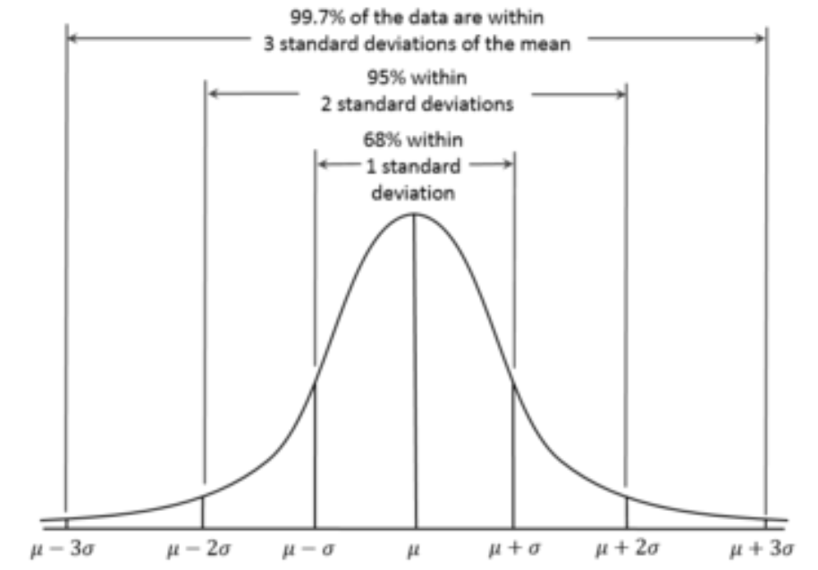

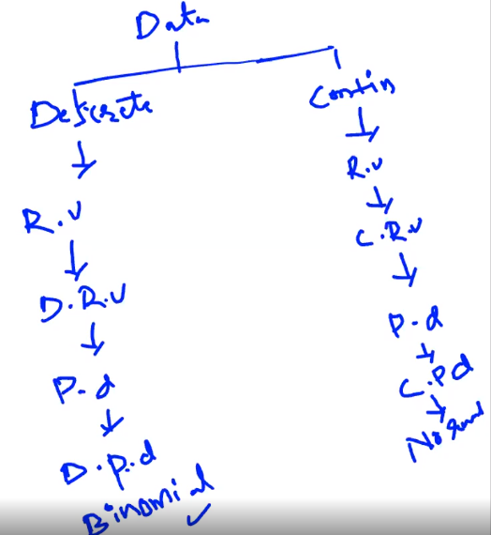

# Inferential Statistics

## Central Limit Theorem Says

* The distribution of the Sample Mean will be normal when the distribution of data in the population is normal.
* Will be approximate normal even if the distribution data in the population is not normal
* Sample size should be “fairly large”. Means sample size should be greater than 30

## Confidence Interval:

Based on descriptive statistics we can comment about the population parameter and using this confidence interval, construct range with min and max values and we will hope that the population parameter would lie in this range with whatever the confidence that we attached to it.

Confidence Interval is the level or interval or range of values with min and max.

## Confidence Level:

Now there is the chance my population parameter may fall within the given confidence interval or it may skip this, now based on how much confidence is stating whether that population parameter lies between that confidence interval or not is nothing but confidence level. If my confidence interval levels narrow range (less difference in max and min values) then my confidence level will drop.

## Significant Level:

Significant level means alpha ie 0.05. significant level says that you can go wrong up to 5% the business allows you to go wrong up to 5% of significant level. Significant level tolerance level up to which you can go wrong not more than that.

# Hypothesis Testing:

Hypothesis testing is a statistical method that is used in making statistical decisions using experimental data. Hypothesis testing is basically an assumption that we make about the population parameter.

Based on irrespective of sample data you want to make inference or an estimate or generalize statement about the population parameter like mean, standard deviation or anything, we conduct hypothesis testing on it. With this I can make generalize statements about the population parameters and given statement should be always reliable on population parameter, we make use of confidence level with confidence intervals(range).

Ex: You say average height of citizens of city more than 5.8 ft.

Votes for the politician will be more than 60%

All those examples we assume need some statistic way to prove those. We need some mathematical conclusion whatever we assuming is true.

Steps in Hypothesis Testing

1. Define the Hypothesis. This is a very crucial part in Hypothesis test. If your definition goes wrong, then all the subsequent steps will go wrong. That is the reason defining the Hypothesis properly based on the problem statement.
   1. Null Hypothesis(H0): It says there is no difference or no change in the argument hence no action needs to be taken
   2. Alternative Hypothesis(H1): It says there is a change and this change suggests us some action needs to be taken.
2. Select the test statistic like Z test, T test, Chi-square test. Based on the problem statement and the data that given, select the relevant test statistic.
3. Compute the test statistic (basically determine the Z or T Value)
4. For the Z or T value, compute the probability (P Value)
5. Based on the above step will get the P value
6. Take α = 0.05. α value always 0.05. Now compare P value with α.
   1. If P < α then reject Null Hypothesis(H0)
   2. If P > α then failed to reject Null Hypothesis(H0)

Example 1: 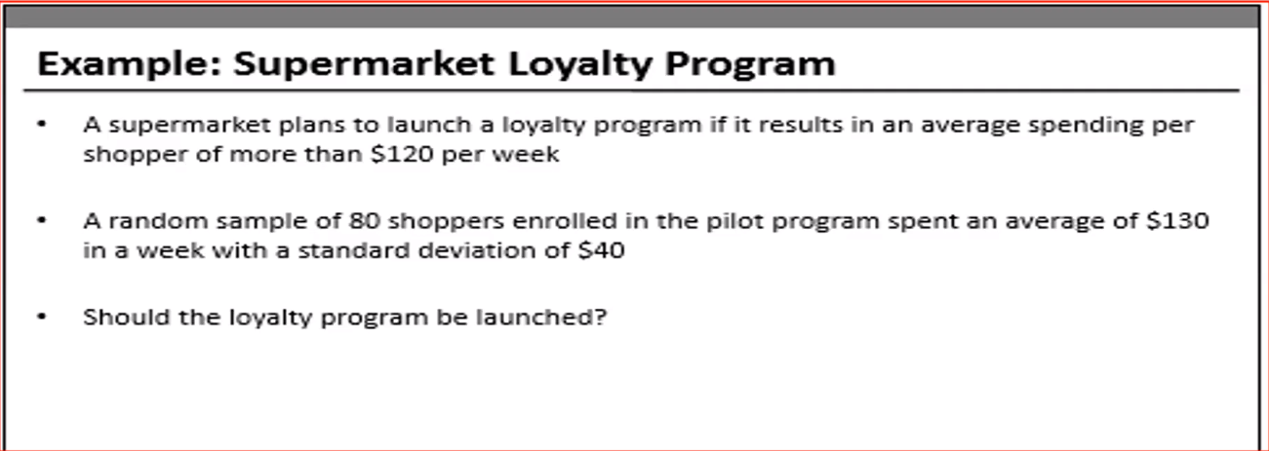

Understandings based on above examples:

Supermarket going to launch the program if average spending per shopper per week is more than $120.

1. H0: µ <= 120 (H0 always tells us “no change/no action to be taken”. No need to start Loyalty Program, just leave as it is)

H1: µ > 120 (H1 always suggests some action to be taken. Need be launched Loyalty Program)

1. Sample size (n) =80; Sample Mean $\overline{x}$ = 130; sample Standard Deviation(s)= 50; Population Mean µ = 120 based on these parameters need to select test statistic.

Here we have Sample Mean and Sample Standard Deviation we must go with T Test.

When we know the Population Standard Deviation, go with Z test and if we don’t know population standard deviation then go with T test.

1. Compute T Test:

t = 🡺 = 2.23

t = 2.23

1. With the T value compute the probability. Probability lies between 0 to 1. When we are creating probability distribution area under the curve is always 1 ie sum of all the probability. With the following python code compute the probability value (P Value)

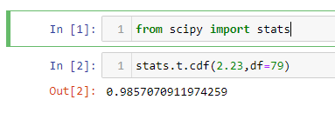

1. P Value = 1 - 0.9857 🡺 0.01
2. α always 0.05 then compare α value with P value.

As P value (0.01) < α value (0.05), reject the null hypothesis that is my µ will be lesser than 120. So, we are rejecting the possibility of µ being lesser than or equal to $120 once the program being launched which means that µ will be greater than 120 when the program launch that is the result should launch the loyalty program. Probability of 1% decision may go wrong.

This example is 1 sample 1 tail test variation.

Judiciary system follows Hypothesis test.

First impression in mind of judge is the guy is innocent until proven guilty (as prisoner). Hence null hypothesis is prisoner is innocent.

Either the guy guilty or not are the only two possibilities. Now based on the evidences what will the judge determine.

There are the possibilities as the guy is guilty and there were the sufficient evidences to proven him guilty and then the judge will consider him as guilty and punish him. It is the correct decision. Suppose the guy was guilty but there were no evidences to prove him guilty then the judge will set him free. It is the wrong decision.

If the guy is innocent and the judge found him as innocent, then judge set him free. It is the correct decision. Suppose the guy is innocent but he was proven guilty and he was punished. It is wrong decision.

Our Judiciary system says that it is ok to set the guilty guy to set him free and there is no harm to him (Type 2 Error) but if you punish innocent guy that is the biggest crime (Type 1 Error).

That is the reason always Judge will guy as the prisoner is innocent unless there is strong evidence against him.

Type 1 Error: When you wrongly reject a true null hypothesis (Guy is innocent but punished him). Probability of committing a Type-I error is the same as p-value that is 0.05 (5%). That means the probability of innocent guy to punish is 5%.

Type 2 Error: When you wrongly accept a false null hypothesis (Guy is guilty but set him free).

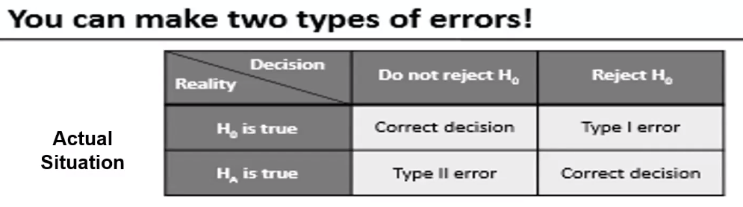

**Variations t-test:**

1-Sample t-test: If you have only one sample dataset and management give you a threshold value or standard value and ask you to compare this dataset with threshold value.

Ex: In the super mart example sample of 80 people average spending is $130, is the threshold value which management has given to us.

2-Sample t-test: if we have 2 different types of data sets Process A and Process B, will compare these 2 datasets whether equal or not.

1-tail t-test: In Hypothesis definition if H0 or H1 has symbols of greater than or lesser than, consider this as 1 Tail Test

Ex: H0: µ > value or H1: µ ≤ value. That means we will see changes or improvements happened on at one side either right side or left side.

2-tail t-test: In Hypothesis definition if we compare mean of two different parameters basically perform 2 Tail Test. if H0 or H1 has symbols of equal or not equal than perform 2 Tail test.

Ex: H0: µ = value or H1: µ ≠ value. In this case we will see changes or improvements happened on both sides. We compute the probability from both side then add both the probabilities to get final probability value.

Anova (Analysis of Variance) Test: When you want to compare more than 2 process, go with Anova test. With this we can know all the process are equal or different. Null Hypothesis is all are equal and alternative Hypothesis is all are not equal. If anyone of them are not equal, all of them are not equal.

Example 2:

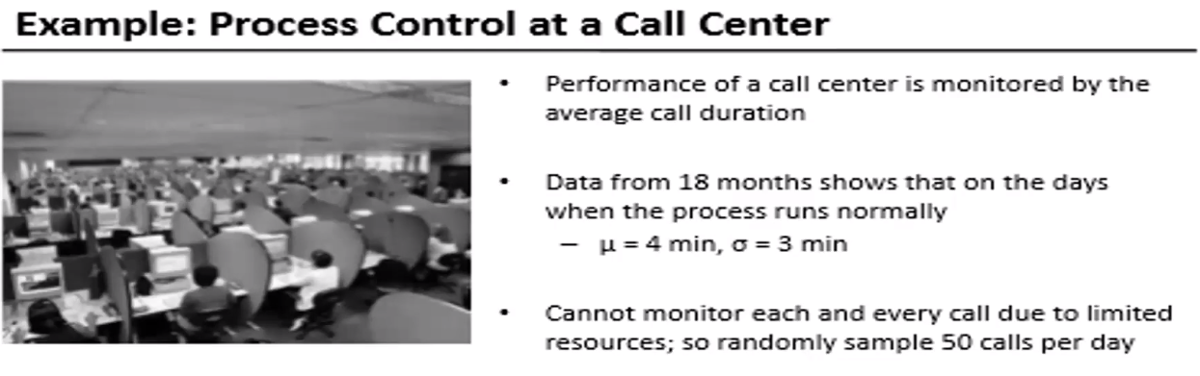

My understanding:

Process of the call center under controlled or not. In the following 2 scenarios the process will be out-off control

1. if there is any network problem, may be cabling problem at call center or may be the server is down or because of any other issue call duration is less than 4 min.
2. if the call center guy not able to resolve the problem, in that case call duration will be more than 4 min.

In general company’s start call center to solve the customers problem. For the above 2 scenarios company need to take an action.

Following are steps:

1. H0: µ = 4

H1: µ ≠ 4 (means µ <4 or µ > 4. Here we are dealing with 2 probabilities)

This is 2 Tail 1 Sample test.

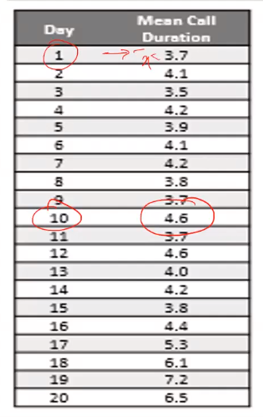

1. Sample size (n) =50; Sample Mean $\overline{x}$ = 4.6; sample Standard Deviation(s)= 3; Population Mean µ = 4 based on these parameters need to select test statistic.
2. Compute T Test:

t = 🡺 = 2.23

t = 1.41

1. Following is the python code to compute P value

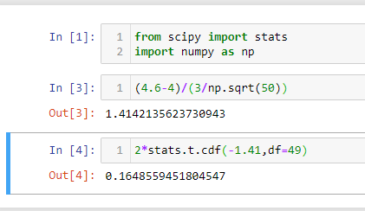

In the above python code “*2*stats.t.cdf(-1.41,df=49)*” irrespective of the sign give minus symbol for t value ie -1.41

1. P value is 0.16
2. α always 0.05 then compare α value with P value.

As P value (0.16) > α value (0.05), fail to reject the null hypothesis that is my µ will be equal to 4 min and on day 19 my process was under control.

**5th day**

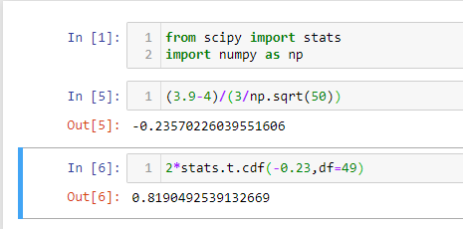

Process is under control on 5th day

**13th day**

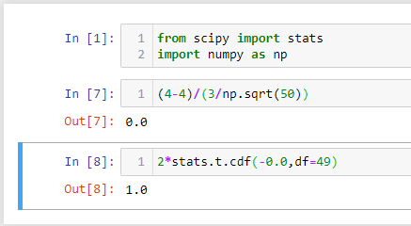

Process is under control on 13th day

**19th day**

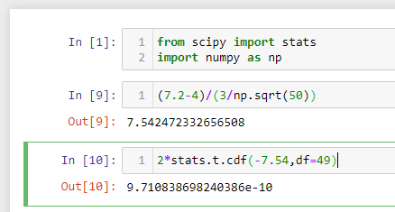

Process is not under control on 19th day

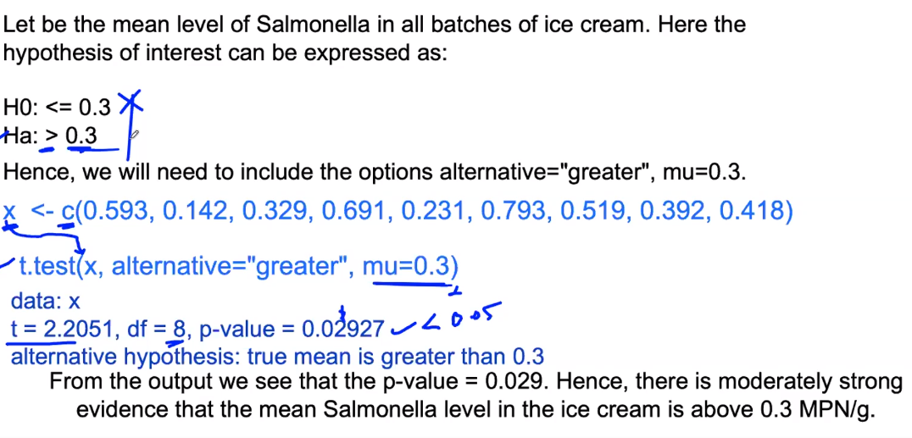

# Anova (Analysis of Variance) Test:

Following is the example

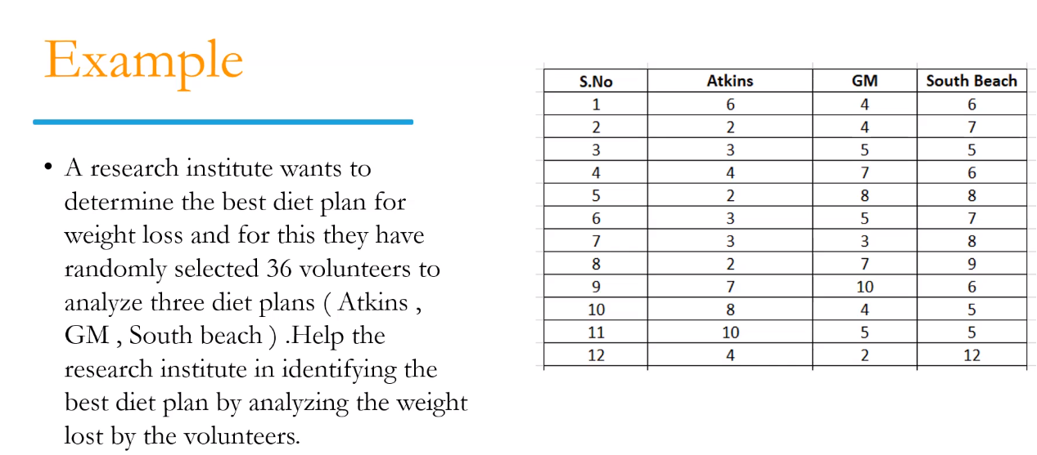

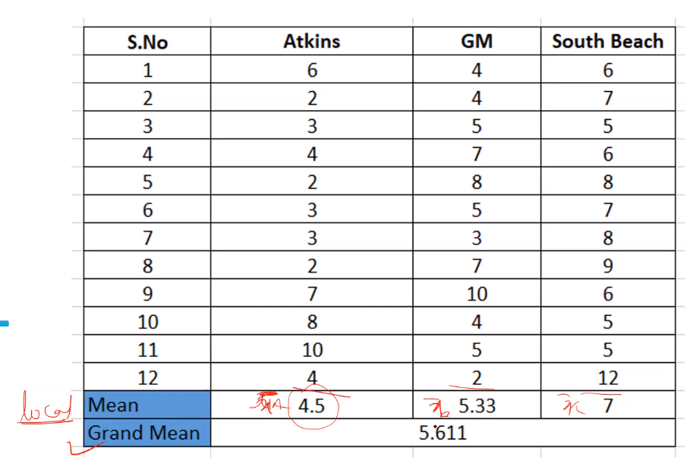

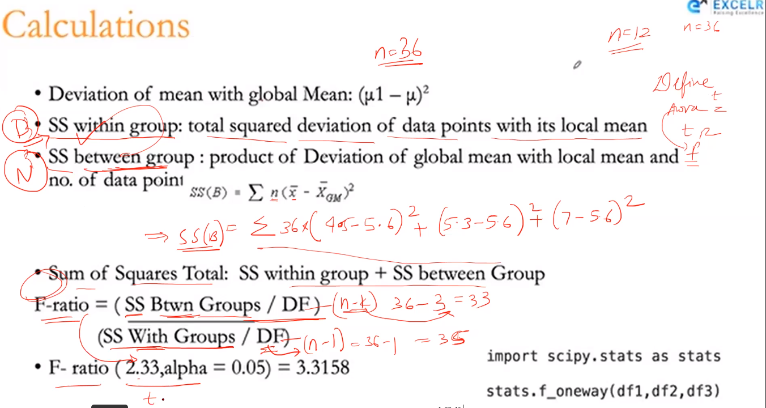

We have checked the IRIS data example, in that Rejected Null Hypothesis.

# Chi square Test ($x^{2}$):

To check the relation between 2 categorical variables whether they are independent each other or relationship between them, use Chi square test.

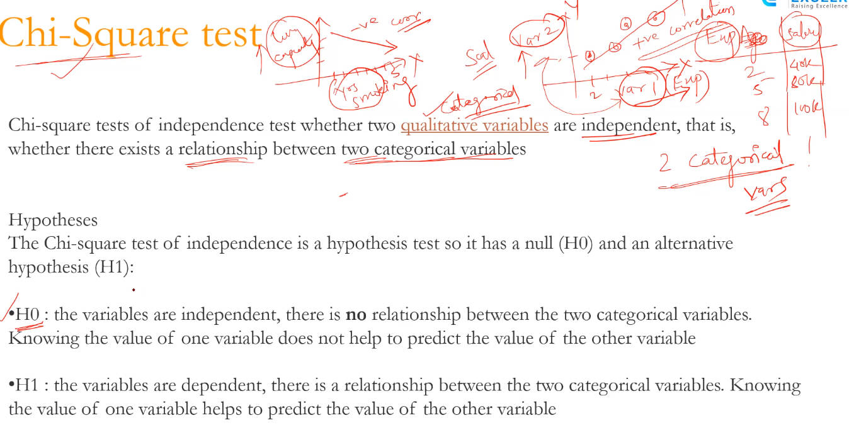

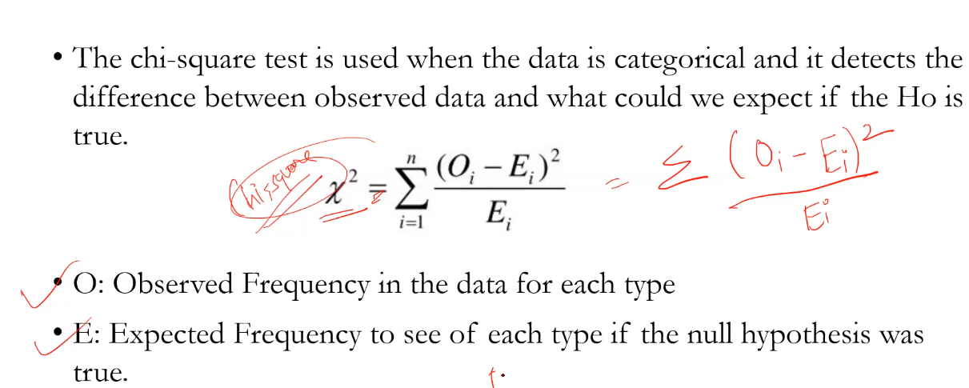

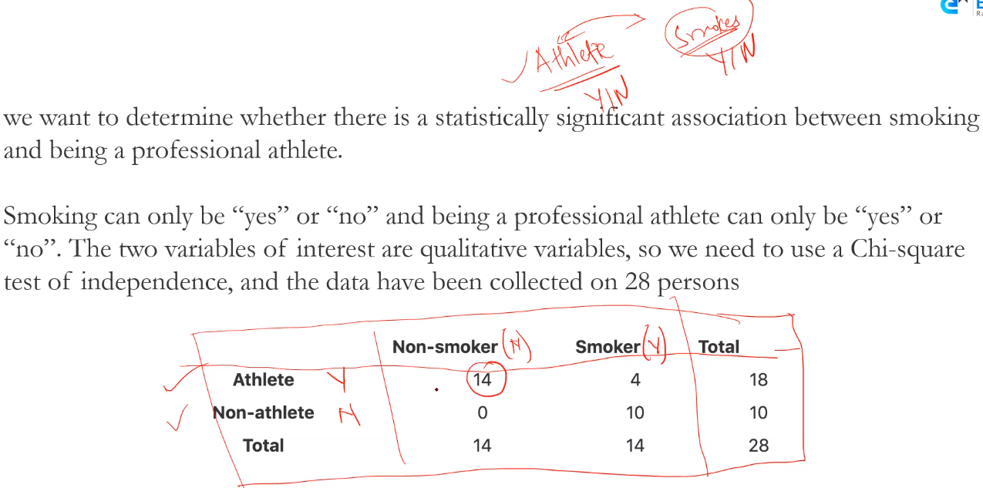

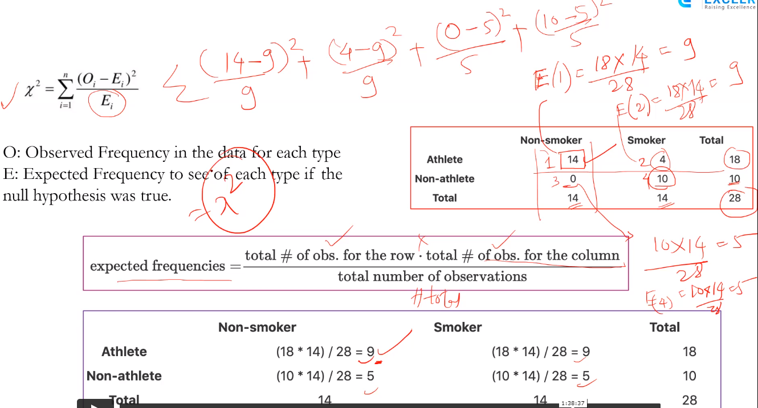

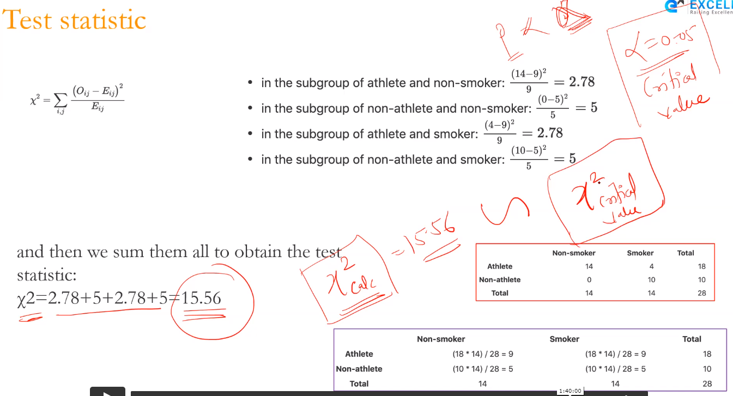

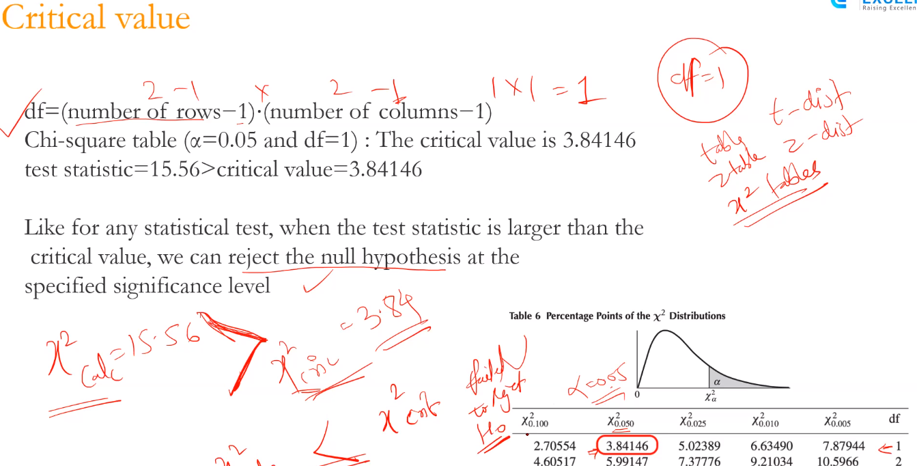

# Data Science Project Life Cycle

Business Understanding: Business Understanding plays a key role in success of any project. Success of any project depends on the quality of questions asked for the dataset.

Every domain and business, work with a set of rules and goals. In order to acquire the correct data, we should be able to understand the business. Asking questions about dataset will help in narrowing down to correct data acquisition.

Data Collection:

There is no Data Science without Data. If asking the right questions is the recipe, then data is your ingredient. So, data serves important ingredient for making any Data Science project. Now the question comes where to get the data from. Data could be from various sources which could be – logs from webservers, data from online repositories, data from databases, social media data, data in excel sheet, so in short data can come from any source. Everywhere data is there. Newspaper, journals, online, websites, everything is made up of data only. If right questions have been asked in prior step, then this becomes an easy step to narrow down to correct data sources.

A major challenge faced by data professionals in data acquisition step, is to understand where the data comes from and whether it is the latest data or not. It is the crucial step to check whether the collected data is relevant to answer the defined problem or not.

Data Understanding:

After business understanding and data collection, the next step is Data understanding. To understand about data, you need to closely work with the business team or SMEs as they are aware of what data is present, what data could be used for this business problem and other information.

This step involves describing the data, their structure, their data type and many other information. Explore the data using graphical plots.

Data Preparation:

After the Data Understanding step, the next step that comes in the life cycle steps is Data Preparation. The collected data may be or may not be in required format. To perform any analytical step on the data it needs to be in certain format. This step is also known as Data Cleaning or Data Wrangling. It includes steps like

* Selecting the relevant data
* Integrating the data by merging the data sets
* Handling the missing values by either removing them or imputing them with relevant data
* Removing duplicates
* Check for outliers and handle them
* Constructing new data, derive new features from existing ones by using the feature engineering.
* Format the data into the desired structure, remove unwanted columns and features to be fed into algorithm.

Exploratory Data Analysis (EDA) plays an important role at this stage as summarization of clean data helps in identifying the structure, outliers, anomalies and patterns in the data. In EDA process apply descriptive statistics, visualization techniques and apply other techniques. These insights could help in finding the right set of features, algorithm to be used for model creation and building the model.

Data collection, Data Understanding and Data Preparation take up to 70% - 90% of the overall project time.

Data Modeling: Data modeling is considered as the heart of data analysis. A model takes the prepared data from the previous step (Data Preparation) as input and provides the desired output. This step includes choosing the appropriate type of model, whether the problem is a classification problem, or a regression problem or a clustering problem. After choosing the model , amongst the various algorithms present. We need to tune the hyper parameters of each model to achieve the desired performance.

The end of modelling is characterized by model evaluation where you measure

Accuracy — How well the model performs i.e. does it describe the data accurately.

Relevance — Does it answer the original question that you set out to answer

We also need to make sure there is a correct balance between performance and generalizability, which means the model created should not be biased and should be a generalized model. For this precision, recall, F1-score for classification problem could be used. For regression problem R2, MAPE (Moving Average Percentage Error) or RMSE (Root Mean Square Error) could be used. Model should be a robust one and not an overfitted model. If it is overfitted model, then predictions for future data will not come our accurately.

Validate the model

Model Deployment:

The model after rigorous evaluation is finally deployed in the desired format and channel. This is the final step in the data science life cycle. Each step in the data science life cycle explained above should be worked upon carefully. If any step is executed improperly, it will consequently affect the next step and the entire effort will go in vain. For example, if data is not collected properly, you’ll lose information and you will not be able to build a perfect model. If data is not cleaned properly, the model will not work properly. If the model is not evaluated properly, it will fail in the real world from giving a perfect output. Right from Business understanding to model deployment, each step should be given proper attention, time and effort.

All the above steps make a complete Data Science project, but it is an iterative process and various steps are repeated until we are able to fine tune the methodology for a specific business case. Python and R are the most widely used languages for Data Science.

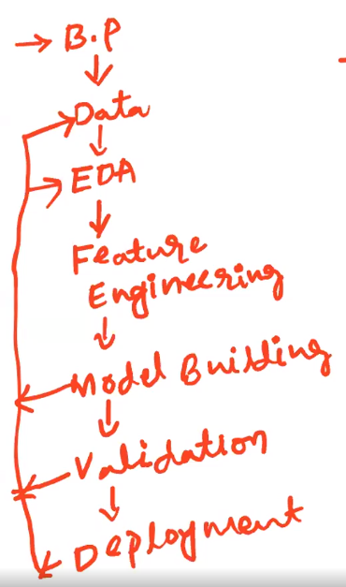

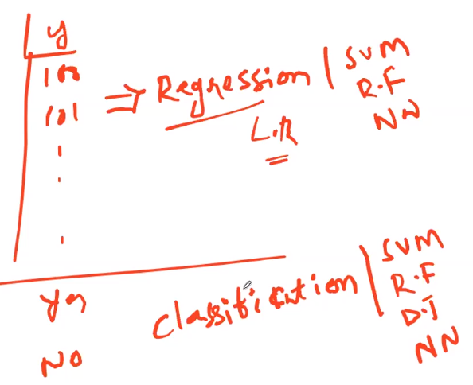

# Roles & Responsibilities of Data Scientist

Data Scientists are analytical experts who have the technical skills to solve complex problems and have the curiosity to explore what problems need to be solved. Data Scientists need to enhance skills of Mathematician, computer scientist and trend-spotter (finding out trends and patterns in data).

Design, develop and deploy the most relevant solutions for your business and share your results with stakeholders.

* Analytics: Explore way to find insights from data by using different algorithms.
* Business understanding: Dealing with business problems and finding best solutions. By talking with product manager, product team understand how things are coming
* Strategy/Design: Interacting with in-house teams and customers. More about best practices you can involve in creating the project.
* Collaboration: Meeting with stakeholders.

|  |  |
| --- | --- |
| **Supervised Learning** | **Unsupervised Learning** |
| Supervised Learning can be used for 2 different types of problems i.e. regression and classification | Unsupervised Learning can be used for 2 different types of problems i.e. clustering and association. |
| Input Data is provided to the model along with the output in the Supervised Learning. | Only input data is provided in Unsupervised Learning. |
| Output is predicted by the Supervised Learning. | Hidden patterns in the data can be found using the unsupervised learning model. |
| Labeled data is used to train supervised learning algorithms. | Unlabeled data is used to train unsupervised learning algorithms. |
| Accurate results are produced using a supervised learning model. | The accuracy of results produced are less in unsupervised learning models. |
| Training the model to predict output when a new data is provided is the objective of Supervised Learning. | Finding useful insights, hidden patterns from the unknown dataset is the objective of the unsupervised learning. |
| Supervised Learning includes various algorithms such as Bayesian Logic, Decision Tree, Logistic Regression, Linear Regression, Multi-class Classification, Support Vector Machine etc. | Unsupervised Learning includes various algorithms like KNN, Apriori Algorithm, and Clustering. |
| To assess whether right output is being predicted, direct feedback is accepted by the Supervised Learning Model. | No feedback will be taken by the unsupervised learning model. |
| In Supervised Learning, for right prediction of output, the model has to be trained for each data, hence Supervised Learning does not have close resemblance to Artificial Intelligence. | Unsupervised Learning has more resemblance to Artificial Intelligence, as it keeps learning new things with more experience. |
| Number of classes are known in Supervised Learning. | Number of classes are not known in Unsupervised Learning |
| In scenarios where one is aware of output and input data, supervised learning can be used. | In the scenarios where one is not aware of output data but is only aware of the input data then Unsupervised Learning could be used. |
| Computational Complexity is very complex in Supervised Learning compared to Unsupervised Learning | There is less computational complexity in Unsupervised Learning when compared to Supervised Learning. |
| Supervised Learning will use off-line analysis | Unsupervised Learning uses Real time analysis of data. |
| Some of the applications of Supervised Learning are Spam detection, handwriting detection, pattern recognition, speech recognition etc. | Some of the applications of Unsupervised Learning are detecting fraudulent transactions, data pre-processing etc. |

# Supervised Techniques Vs Unsupervised Techniques

Machine learning is a subset of Artificial Intelligence (AI) which provides the ability to learn automatically and improve from experience without being explicitly programmed. Machine learning involves continuously feeding data to a machine so that it can interpret this data, understand useful insights like detect patterns or identify key features to solve problems.

Types in Machine Learning:

|  |  |  |  |
| --- | --- | --- | --- |
|  | **Supervised** | **Unsupervised** | **Reinforcement** |
| Definition | Supervised learning is the method in which we train(teach) the machine using labelled(training) data. Here the input and output are labelled data. | In unsupervised learning, the machine is trained on un-labelled data without any guidance/supervision. It discovers hidden patterns and trends in the data | In reinforcement learning an agent interacts with its environment by producing actions and discovers errors and rewards. |

Data mining or Machine learning has 2 branches one is Supervise machine learning and other is unsupervised machine learning. Following is diagram showing the techniques under supervise and unsupervised machine learning.

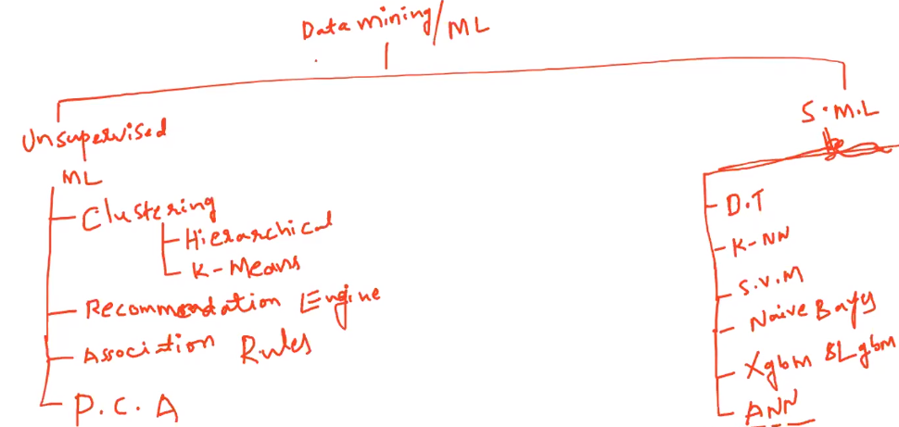

Regression also comes under Supervised Machine Learning technique.

# Simple Linear Regression

Regression analysis is the predictive modeling technique. It estimates the relationship between a single dependent (target) and a single independent(predictor) variable.

# Multi Linear Regression

What is Regression?

In statistical modeling, regression analysis is a set of statistical processes for estimating the relationships between a dependent variable and one or more independent variables. With the regression analysis model can predict the futuristic values hence also called this model as prediction model.

X variables are independent variables and it will be denoted as X1, X2, X3……… These variables don’t depend on any other variables.

y variable is called as dependent variable also called as business interest variable. This variable depends on independent variables.

Correlation gives us the quantification of how much variable depends on other variable or the association between two variables.

We can find correlation with one independent variable with another independent variable or one independent variable with dependent variable

Independent variables are assumed as independent to each other but if they are dependent means they have some relationship between them, and if there is high correlation between independent variables then it creates the problem of multi collinearity that’s the reason we need to check correlation between independent variable with dependent variable and within two independent variables.

Correlation coefficient(r) denoted by small r: it gives us the information of linear relationship between two variables.

Strong relationship is if the points lies close to a straight line and weak relationship is if the points are widely scattered.

Following is the example for widely scattered data points: Scattered means all the data points are in the plot.

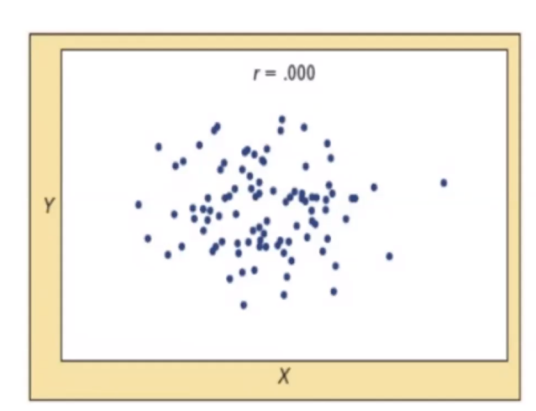

Interpretation of correlation coefficient value:

Correlation coefficient(r) value always lies between -1 to +1

If r value is either -1 or +1 means strong correlation between variables. That means if we change one variable then other variable also changing equal amount. These two variables are strongly associated

If r value is between 0.1 to 0.3 means very weak correlation that means one variable is not influencing another variable

If r value is between 0.4 to 0.7 means moderately correlated

If r value is between 0.8 to 1 means strongly correlated means one variable influences another variable.

In positive correlation if x variable increases then y variable also increases

In the negative correlation if x variable increases then y variable decreases

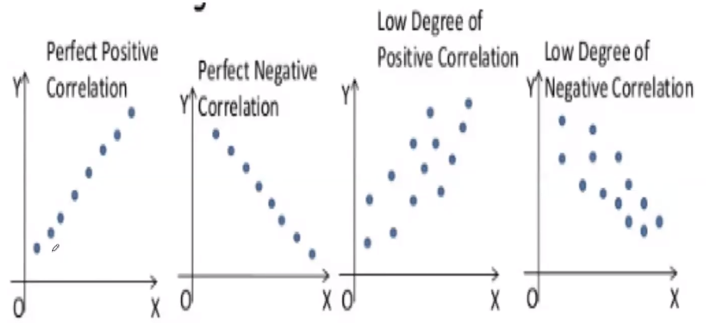

Need to know how the data points are scattered whether linearly or non-linearly. It doesn’t give any information with non-linear Relationship between two parameters that is x and y variables.

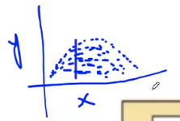 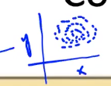

Non-linear relationship means at some point of time as X increased y also increased after that it stagnated then decreased. And it can be circular format.

If you compute correlation for non-linear relationship variables, you might get correlation value as 0.

Correlation co-efficient gives linear relationship value only and for non-linear relationship we have other methods to compute.

Mathematical Equation is: Y = mx + c +e

m = Slop of regression line, c = y intercept, e = error

slop is if we change the value x by one unit, how many units of y getting changed.

y intercept means where the regression line touches in y axis.

Scatter Diagram:

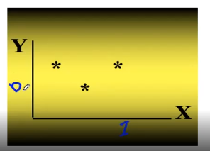

it is very import diagram for all the algorithms. We can scatter two quantitative variables. One is independent variable(x) and other is dependent variable(y)

Once we get the dataset, first need to visualize the dataset to see the dataset structure and pattern

Dot Plot:

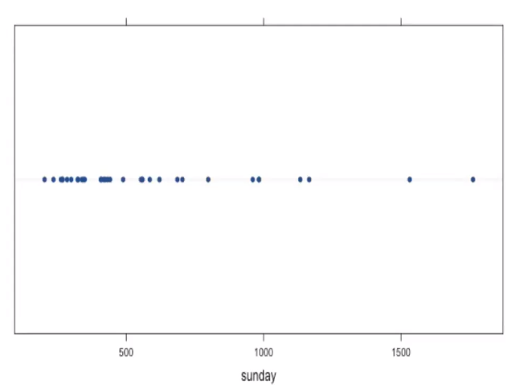

It gives the information of the range of the columns.

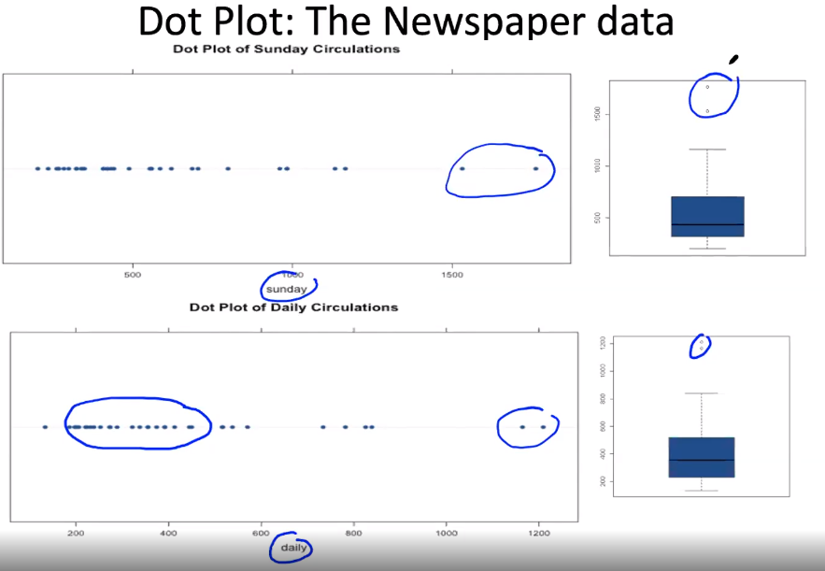

With this we can know where most of the data points existed and know the outliers.

Best fit line is which closest to all the data points.

Ordinary Least Squared (OLS) method: Distance between the datapoints and associated regression line point then sum it up will get the value. Among them lowest maintaining value line is called best fit line.

Error value means distance between the actual data points and associated regression line points

Sum of the squares of all the error values (distance between the actual datapoints and associated regression line points) and whichever line is gives me the least value that line is called Best fit line

$\hat{y}= β_{0}$**+ $β_{1}$ x + $ϵ_{1}$**

$$\hat{y}=Predicted Value$$

$$β_{0}=Intercept$$

$$β_{1}=Slop$$

$ϵ_{1}=$***Residual (Errors) that we didn’t capture***

***x = input value to predict***

***Slop = $\frac{y_{2} - y_{1}}{x_{2 }- x_{1}}$***

y is dependent variable

x is independent variable

Formula to best fit slop ( $β_{1})$ and best intercept ($β_{0})$

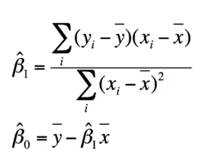

**Co-efficient of Determination ($r^{2}$):**

By using Co-efficient of Determination ($r^{2}$) we can check the health of the regression (prediction) line whether to use or not

$r^{2}= \frac{explained variation}{total variable}$**= $\frac{SSR}{SST}$**

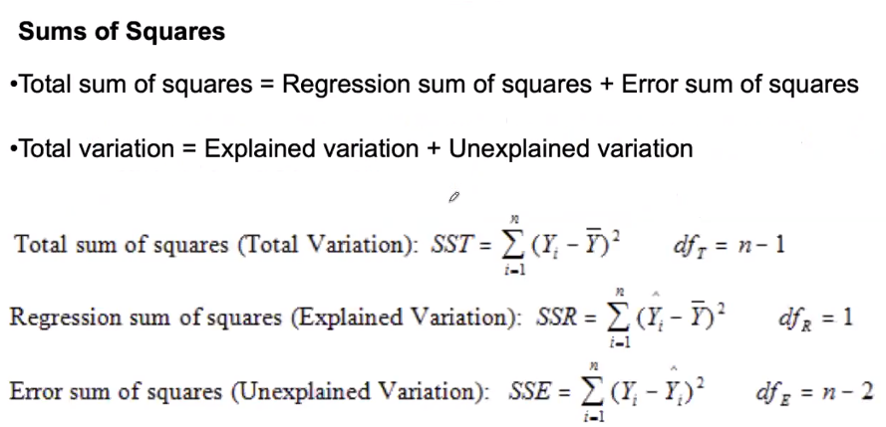

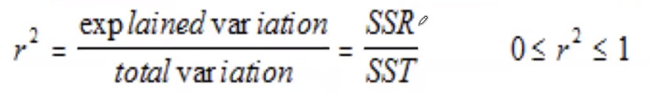

Based on the above formula we find $r^{2} value$

$r^{2}$ means how much variation in y (dependent variable) is being explained by x (independent Variable) that means x is having the influence on y variable, if x is changing y also changing that means x varies y also varies.

$r^{2}$ = Explained Variation / Total Variable

$r^{2}$ is 1 means very good regression line and 0 means bad regression line (no relation with x and y)

If $r^{2}$ value is closer to 1 or greater than 0.8, that regression equation is good and if it is closer to 0 it is not at all good equation (bad) it means x variable not at all influencing y variable

**Residual ($ϵ_{1})$ Analysis:**

Residuals are nothing but errors from the regression equation.

Errors means distance between data points to regression equation

**Multiple Regression:**

When the $r^{2}$ value is low and if you want to increase the reliability of regression equitation, you must add other relevant factors/variables into regression equitation

If p value less than 0.05 then dependent variable is significant variable otherwise will through it away

**Collinearity:**

Highly correlated independent variables might cause a problem in the dataset is called collinearity.

**Confidence Interval Vs Confidence Level Vs Significant Level**

Confidence Interval is the level or interval or range of values with min and max

Now there is the chance my population parameter may fall within the given confidence interval or it may skip this, now based on how much confidence is stating whether that population parameter lies between that confidence interval or not is nothing but confidence level. If my confidence interval levels narrow range (less difference in max and min values) then my confidence level will drop

Significant level means alpha ie 0.05. significant level says that you can go wrong up to 5% the business allows you to go wrong up to 5% of significant level. Significant level tolerance level up to which you can go wrong not more than that.

**Multi-linear Regression Model Assumptions:**

* All the parameters are linearly correlated. There is no non-linear relationship between the variables (parameters) ie x on y or x on x
* Mean of all Errors should be zero
* Errors should have constant variance
* Input or x variables are non-random
* Data points which we collected are without errors. There is no input or type error while collecting the data
* x variables or input variables are linearly independent to each other
* All the data points which collected are equally reliable there is no data collection error or any kind of error. All data values are reliable that means the actual data which we collected.

Adjusted R-squared value means, if we create another equation by adding other x variables to the original equation is having influence or determining my y then my adjusted R-square also change.

If x variables p value is less than 0.05, these are significant with y variable.

If the slop is zero, whatever value of x, y is not getting influenced.

$\hat{y}= β_{0}$**+ $β_{1}x_{1}$ + $β_{2}x_{2 }$ + $ϵ_{1}$**

As per the Hypothesis test, if p value less than 0.05, reject null hypothesis and accept the alternative hypothesis that means slop is not zero. If p value greater than 0.05 means, accept null hypothesis that means slop is zero. In the above equation if slop ($β_{1}$) is zero, then x variable value also becomes zero (0 multiply with $x_{1}$ variable). That means $x_{1}$ variable not influencing on y variable for creation of regression line equation.

If any x variable p value is not less than 0.05, then we need to check the impact of y variable with x variables individually or need to check all the combinations of x variables. For example if x variables are x1, x2, x3, x4 then need to check with x1, x2 variables with y variable, x1, x3 with y, x1, x4 with y, x1, x2, x3 with y like that check all the combinations.

If one x variable is influencing on other x variable, x variables individually influencing on y variable and combination of x variables are not influencing on y variable, we can exclude one x variable.

Ex: When we check p values on model (*MPG~WT+VOL+SP+HP),* HP and WT variable p values are greater than zero means slop is zero. But in general, these HP and WT variables are influencing in generating MPG (y) value so we need to check p value in *MPG~WT****,*** *MPG~VOL* and *MPG~WT+VOL*, if both *MPG~WT and* *MPG~VOL* p values less than zero, VOL & WT variables are perfectly correlated (r=1) and *MPG~WT+VOL* p value greater than zero, there is the collinearity problem.

x variables are individually significant with y but when combining x variable, not significant with y variable that is nothing but multi-collinearity problem.

To detect multi-collinearity, first thing to see is “correlation matrix” then check Variable Inflation Factor (VIF)

Correlation Matrix example as follows

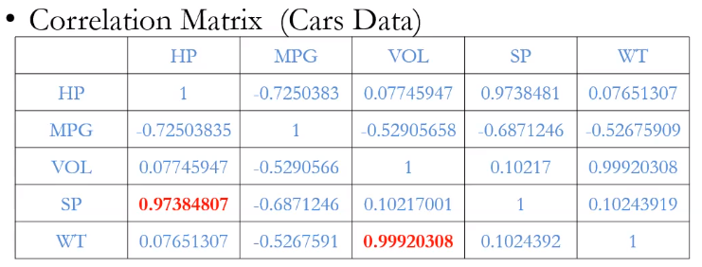

Variable Inflation Factor (VIF):

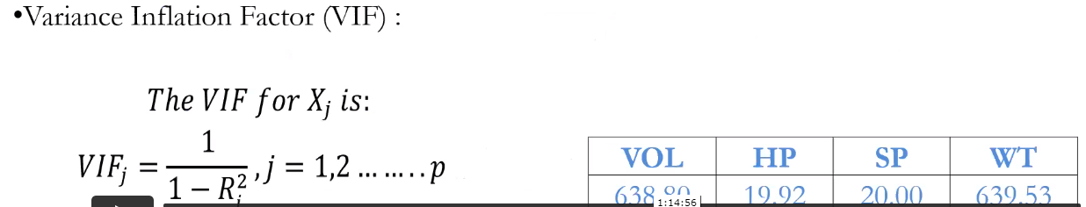

With the above formula calculate VIF for all the x variables individually. Industrial standards any VIF closer to 10 in some particular cases it can be 15 for the max accepted value is 20 but if anything goes beyond 20, means there is some issue with these variables.

With these two methods gives us which of the variables are having multi collinearity problem.

Solutions/remedies for collinearity problem:

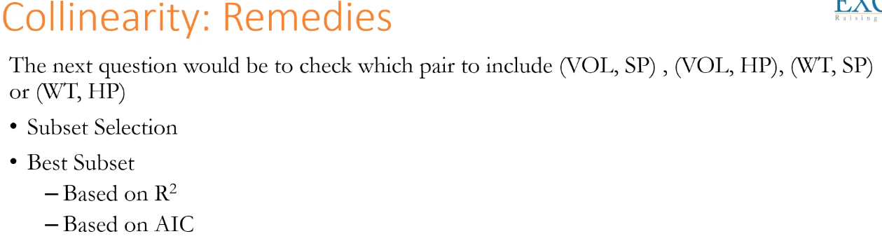

Subset selection means it will check y variable with all the x variables individually ie MPG~WT, MPG~VOL, MPG~HP, MPG~SP then check the AIC values. Then check all the possible combination(pair wise) of x variables MPG~WT+VOL, MPG~WT+SP, MPG~WT+HP, MPG~WT+SP, MPG~VOL+SP, MPG~VOL+HP, MPG~SP+HP, MPG~WT+WT+SP, MPG~WT+WT+HP, it is difficult to calculate all the combinations manually. With python library gives us which combination is going to give us the least AIC and high R-square, is the best model and consider that is the best subset value.

AIC 🡪 Akaike Information Criteria

BIC 🡪 Bayesian Information Criteria

Model Validation Technique: It determines, how good is your model. Here we study the errors. And based on the errors, we are going to determine how good is your model.

In the dataset if we have patterns and my model captures patterns (basically my model leart the patterns), in that case the error patterns are randomly distributed.

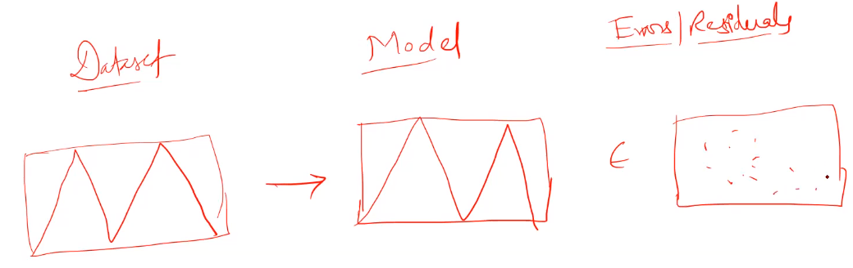

In the above example if there are no patterns in errors, it is a good model. If we found patterns in errors, that means our model is randomly distributed and which indicates our model is not good.

We need to 3 different plots to check

1. Error values with predicted values: This should not be any patterns

2. Error values with predictors (actual x values): this should also not contain any patterns

3. Q-Q plot: Fitted values (y hat) vs residuals (errors): No patterns means no problem. Model is good if residual mean is zero. No patterns in the errors means model captured patterns correctly. Example is as follows.

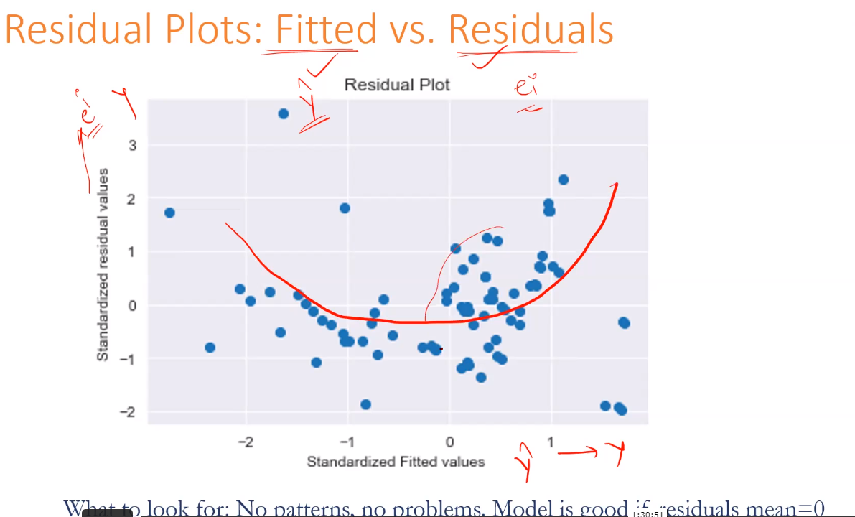

Check for normality of error points with QQ-plot:

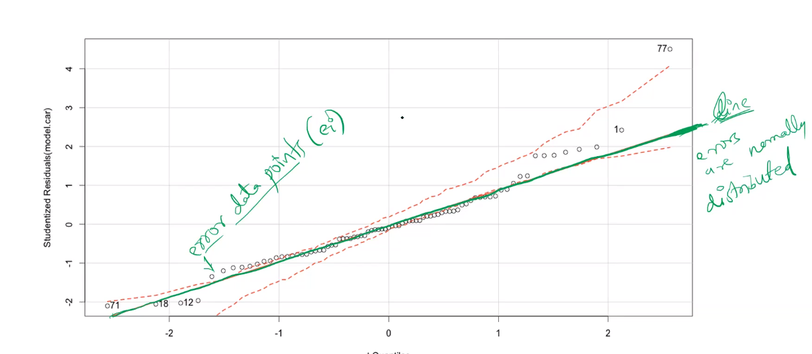

In the above example, errors are normally distributed. All the error data points are closed to the line means errors are normally distributed. In the above example red colored doted lines are confidence intervals. Even all the error data points fall with in confidence interval, still consider as Errors are normally distributed.

x variables also called as input variable, regressors, predictors, independent variables, dimensions, features.

y variables also called as output variable, target variable, dependent variable, predicted variable

Model Deletion Diagnostics: it is nothing but need to detect the outliers and get them to delete.

We have 2 different techniques

1. Cooks distance: The distance/difference between the fitted (Regression co-efficient) values obtained from the full data and the fitted values obtained by deleting the ith observation. y hat values with full data and y hat values with deleting the ith observation. That distance is greater than 0.5 is the significant but greater than 1 is definitely outlier.

Regression co-efficient means beta values.

1. Hat-points / Leverage value / Influence: whether the regression line fitting correctly or not, it is influence of hat-points.

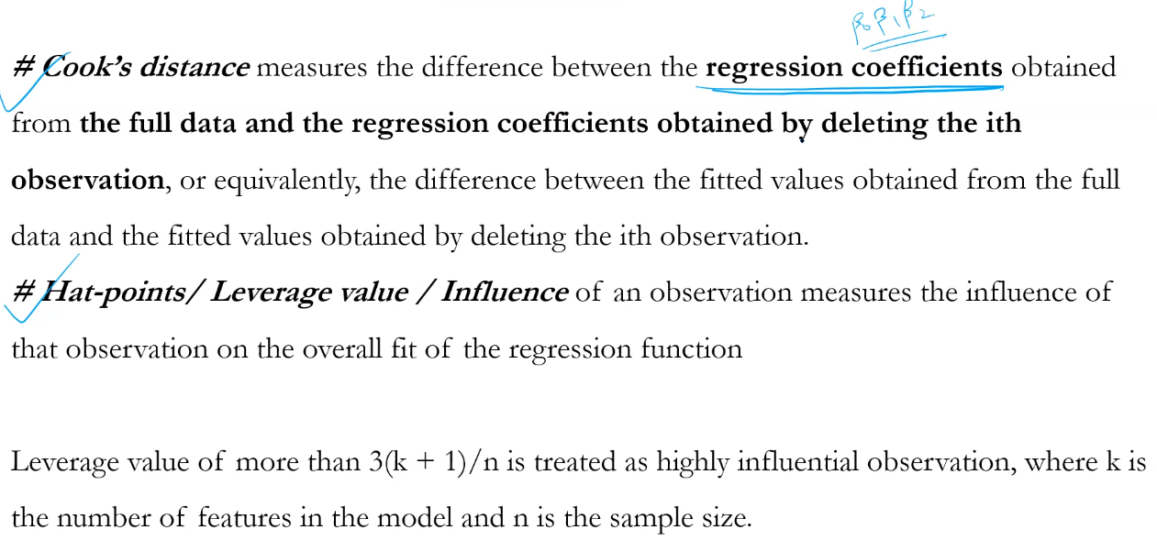

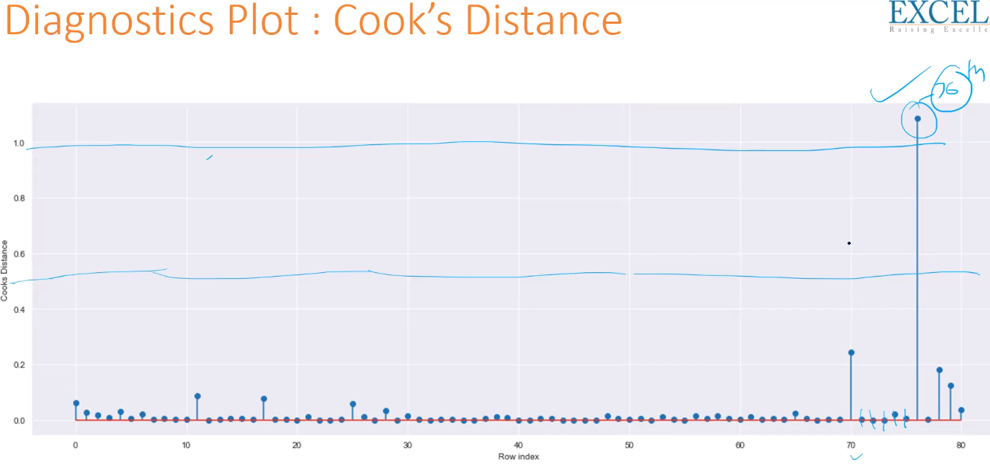

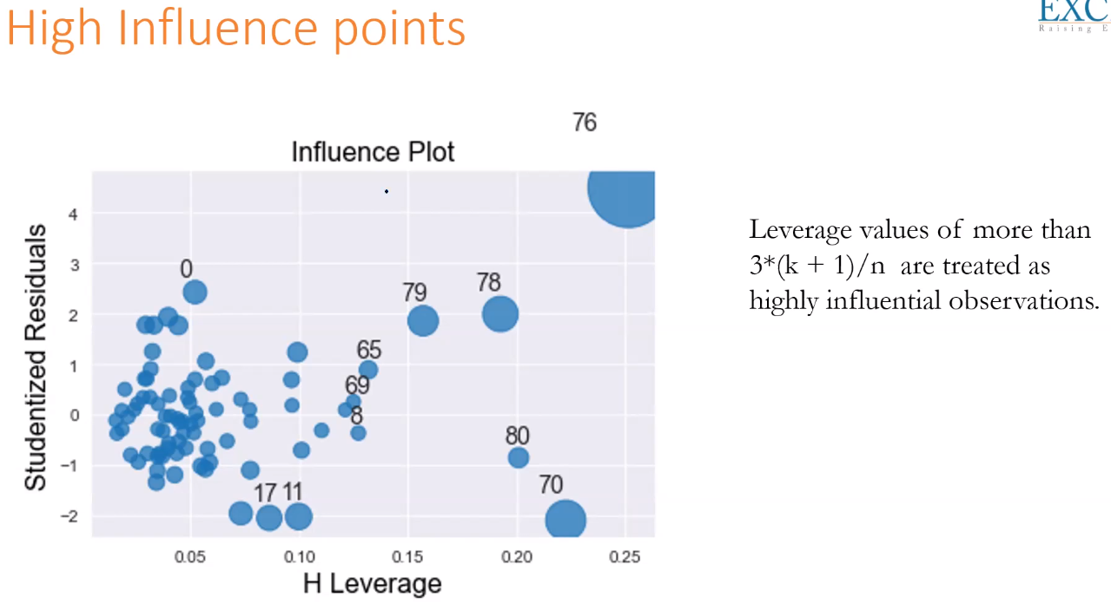

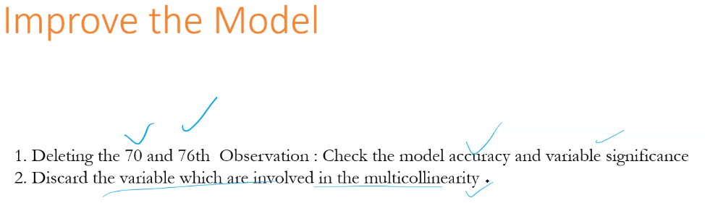

With rsquared value we can know how good our model is? If the rsquared value is greater than 0.8, then model is moderate. If it is near to zero, then model is bad.

r2 = explained variation / total variable

if the value is less than 0.8 means, the complete variation is not explained by these variables (whose p value less than zero), which means that some other factors (whose p value greater than zero) involved to determine y variable

significance of rsquared_adj is

if we add a variable to my regression equation, if this additional variable really contributing in determining my y variable, in that case my rsquared_adj value will be increased. If it really influencing value will move up and vise versa.

**Multiple Linear Regression Practical:**

*model = smf.ols('MPG~WT+VOL+SP+HP',data=cars).fit()*

~ is regressed on

Create the model with y variable regressed (~) on all the x variables and fit the ols (ordinary least square) methodology on the given data (cars).

To resolve collinearity problem in the above scenario, we can exclude either VOL or WT variable based on R-square value and Adj. R-Squared value.

If R-square value near to zero, it is not influencing on y variable and there will be other factors are there to influence y variable.

Understand where the x variables p value is less than 0.05

# Logistic Regression

Logistic regression produces the results in a binary format which is used to predict the outcome of the categorical dependent variable. So, the outcome should be discrete/categorical such as: 0 or 1, True or False, Yes or No, High or Low.

With Linear Regression we can predict on numerical values and can’t predict on binary values (y or n) or categorical (Grant loan or Reject loan) also called as binary classification. Following are the examples

* Whether credit card application would be accepted or rejected, here y variable is yes (y) or no (n).
* Whether the loan application is approved or not.
* Based on patient data whether this patient has cancer or not
* Financial community – whether bankrupt or not

We can code dependent variable values y as 0 and n as 1

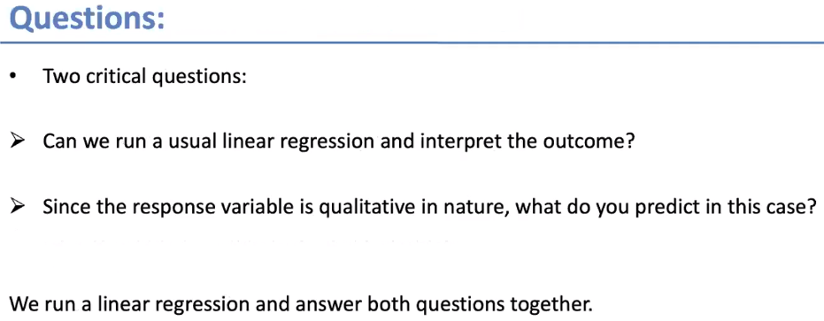

Can we use normal regression equation to find out the outcome?

Since dependent variable is qualitative (0 or 1) in nature, what do you predict with normal regression equation?

In Linear regression, y(predicted) values will be range from - $∞$ to + $∞$, there is no limit and we can’t bound it. But whereas in logistic regression we are predicting the probability but not predicting the values. Probability always bound between 0 to 1. Our goal is to bound predict the value either 0 or 1 because of this we can’t go with Linear regression hence use the Logistic regression.

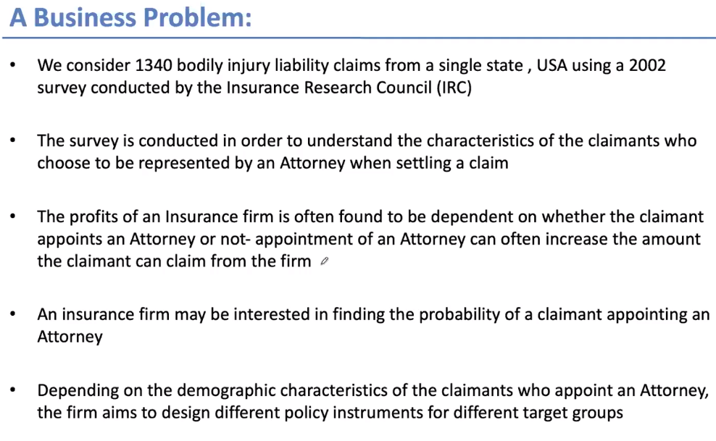

Insurance research conducted a survey on 1340 accidental insurance claims from a single state

If the claimants submit the claim by appointing attorney, as attorney includes other factors and help to get more claim amount to claimant, but this leads loss to insurance firm.

Based on demographic characteristics of the claimant who appoints an attorney, the insurance firm designs different policy to get more premium amount from these groups.

Based on customer characteristics need to predict whether this person appoints attorney (y) or not (n)

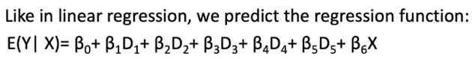

In the above equation 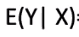 means find the expected (conditional probability) value of Y given X. With the above function/equation, will bind the output(Y) value between 0 to 1 irrespective values of X.

But in Linear Regression Y variable regressed (~) on all the X

Following are the problem face when we apply OLS method on binary response variable data.

* Not all predicted values lie between 0 and 1
* Some predicted/probability values can get negative or more than 1.

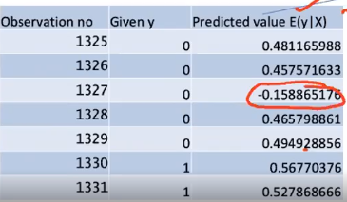

Problems when you apply OLS (Linear Regression) method on binary response variable data (0,1)?

In the above the predicted (output of the regression) values are can be less than 0 or greater than 1 but the probability values should lie between 0 to 1

Because of these reasons we go with logistic regression model which will transforms the predicted values and put them between 0 to 1

Sigmoid is one of the mathematical equation that transforms the output of linear regression values and put them between 0 to 1 that means will get the output from the linear regression with OLS method and whatever the values it is, will transform that values between 0 to 1.

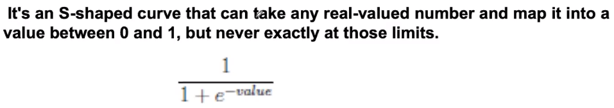

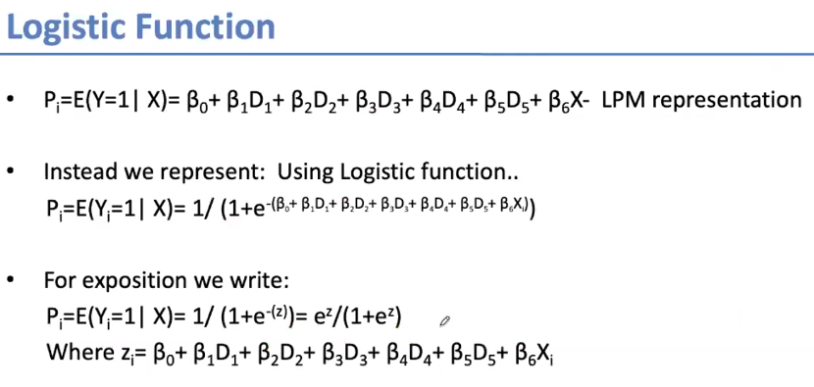

Odds ratio:

Odds ratio = $\frac{Pi}{1-Pi}$ that is $\frac{Probability of success ration}{Probability of failure ration}$

If the odds ration>1 means numerator (Pi) is higher than the (1-Pi) denominator. Pi should be greater than (1-Pi) that means probability of success is more than the probability of failure. If odds ration <1 vice versa.

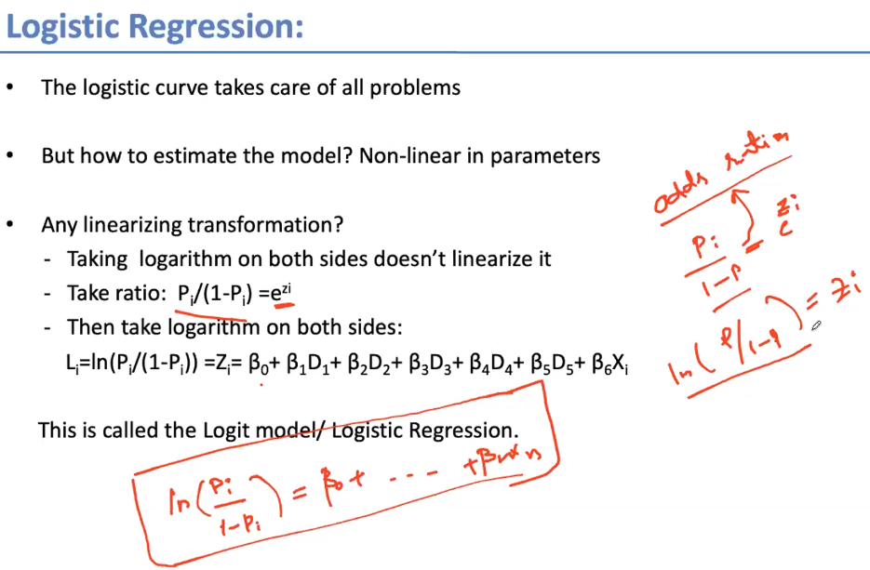

Final logistic regression equation is



The value of the logistic function between 0 and 0.49 convert that to 0 and for the value between 0.5 to 1 convert that to 1 to classify into binary model that is 0 or 1.

Why not linear regression:

In Linear regression the value Y which need to predict in range(numerical) but in logistic regression which has only two values it can be 0 or 1. Values should not be less than 0 or greater than 1

|  |  |
| --- | --- |
| Linear | Logistic |
| Y value is continuous variable | Y value is categorical variable |
| Solve the regression problem. Y variable (prediction value) is always in range between – infinity to + infinity | Solves the classification problem. It gives the result as 0 or 1 |
| Graph is in straight line | Graph is in S-curve |

Maximum likelihood estimation:

For which regression AIC value is low, that regression equation is good.

Null deviance: It is nothing but errors. If we don’t have all the variables in the regression equation and it is simple average, is called null deviance.

Residual deviance: It is nothing but errors. When you have all the variables in the regression equation, what is the error, is nothing but residual deviance.

Residual deviance should be lower than null deviance. If it much lower that regression equation is good.

Model Validation:

Confusion Matrix: It is one of the model validation technique. We will find the accuracy of the model by using confusion matrix.

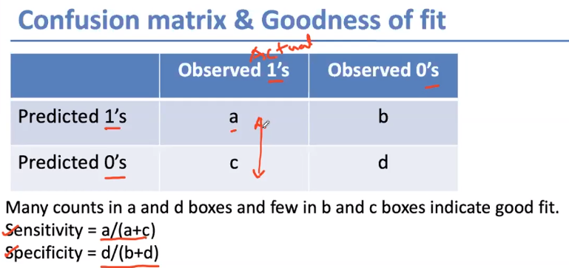

Accuracy of the model = a+d/a+b+c+d

Sensitivity means to find out how good your model is to predict 1’s

Specificity means to find out how good your model is to predict 0’s

High sensitivity and specificity indicate model is good fit.

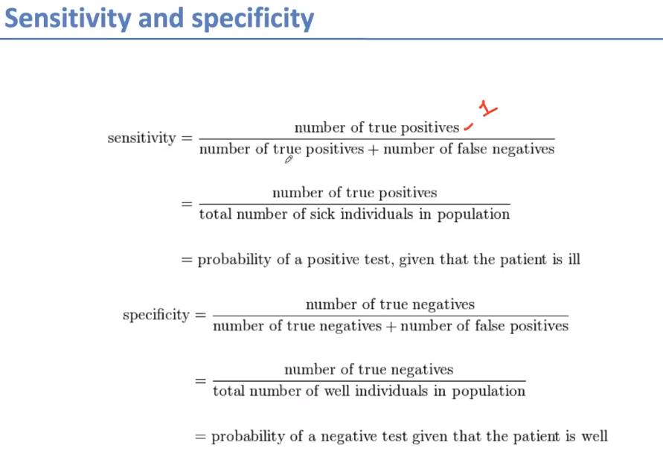

ROC (Receiver Operating Characteristics) Curve: It is another way of finding model accuracy.

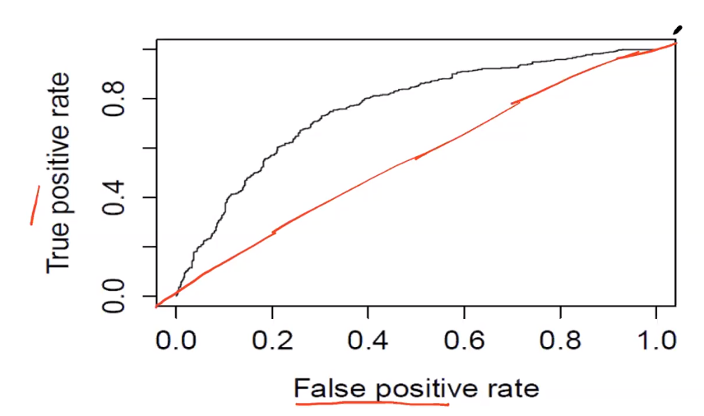

In the above graph we have False positive rate and True positive rate. When we have multiple datasets of yes and no, the dataset will build similar like above curve.

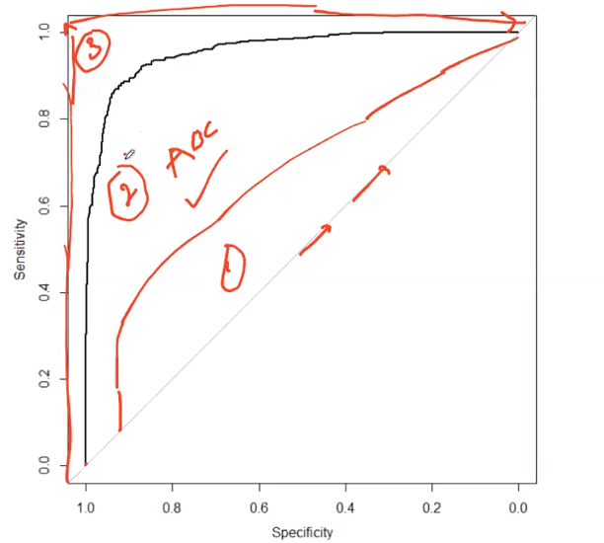

In the above Area Under the Curve (AUC not ~~AOC~~) is bigger is the better the model. In the above 3 models, model 3 is better than model 2 and model 2 is better than model 1. The more the area under the curve, is the better model. If the more area means, for a greater number of data points model is predicting correctly

# EDA Techniques:

Exploratory Data Analysis

* Data Cleaning
* Imputation Techniques: How to impute/replace the missing value
* Data Analysis and Visualization (scatter diagram, correlation analysis)
* Transformations: transform the values by using square, square root, log, standardize them into z score that is basically bringing them into similar scale
* Auto EDA library

Describe a dataset: Number of rows / columns, missing data, data types, preview.

Clean data: Handle missing data, invalid data types, incorrect values and outliers

Visualize data distribution: Bar chart, histogram, box plot.

Calculate and Visualize: correlation(relationship) between variables, Heat map

Data Cleaning: Data cleaning or data cleansing is the process of detecting and correcting the corrupt or inaccurate records from a dataset. Identifying the incomplete, incorrect, inaccurate or irrelevant parts of data and then replacing, modifying or deleting the records.

Data Quality

Validity:

* Datatype constraints: values in a particular column must be of a particular data type e.g. Boolean, numeric, date, etc.
* Range constraints: typically, numbers or date should fall within a certain range.
* Mandatory constraints: certain columns can’t be empty
* Set-membership constraints: values of a column come from a set of discrete values e.g. blood groups – fixed set of discrete values
* Regular expression patterns: text filed that have to be in a certain pattern. For example, phone number may be required to have the pattern (999) 999-9999.
* Cross filed validation: certain conditions that span across multiple fields must hold. For example, a patient’s date of discharge from the hospital can’t be earlier than the date of admission.

Accuracy:

The data is close to the true values. While defining all possible valid values allow invalid values to be easily spotted, it doesn’t mean that they are accurate. E.g. A valid street address mightn’t exist.

Another thing to note is the difference between accuracy and precision. Saying that you live on the earth is true. But, no precise. Where on earth? Saying that you live at a particular street address is more precise.

Consistency:

The degree to which the data is consistent, within the same dataset or across multiple datasets. Inconsistency occurs when two values in the dataset contradict each other. E.g. 3 years old age kid mightn’t match with the marital status married or divorced. A customer is recorded in two different table with two different genders.

Uniformity:

The degree to which the data is specified using the same unit of measure. E.g. The weights may be recorded either pounds or kilos. The date must follow US format or European format.

Outliers: Outliers are data that is different from other observations. They could be real outliers or mistakes. By using Histogram or box plot we can find the numeric values of outliers. By using bar chart, we can find the categorical variable.

The method of handling outliers are somewhat similar to missing data.

Data cleaning steps:

* Duplicate rows
* Rename the columns
* Drop unnecessary columns
* Convert datatype to other types
* Remove strings in columns
* Outliers

Treat missing values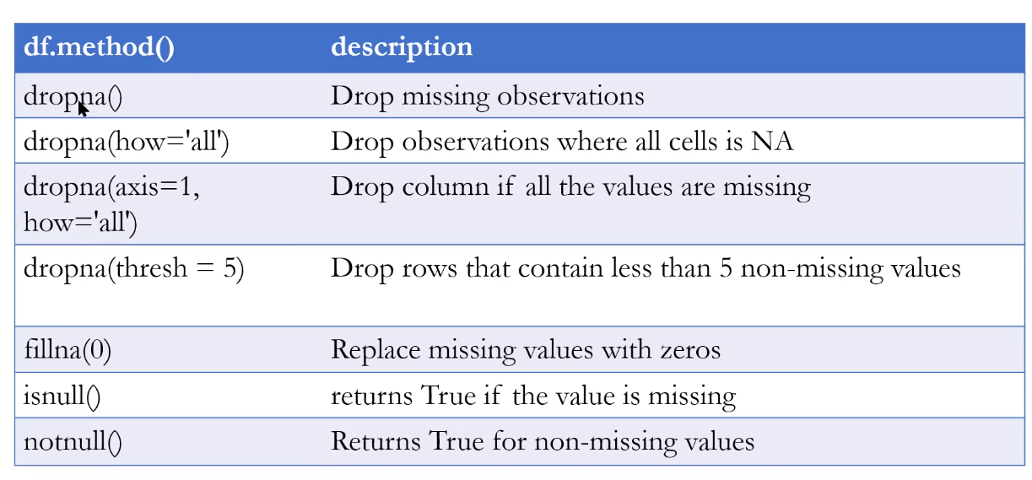

# Feature Selection

<https://machinelearningmastery.com/feature-selection-with-real-and-categorical-data/>

<https://machinelearningmastery.com/feature-selection-machine-learning-python/>

Feature selection is the process of reducing the number of input variables when developing a predictive model.

It is desirable to reduce the number of input variables to both reduce the computational cost of modeling and, in some cases, to improve the performance of the model.

Statistical-based feature selection methods involve evaluating the relationship between each input variable and the target variable using statistics and selecting those input variables that have the strongest relationship with the target variable. These methods can be fast and effective, although the choice of statistical measures depends on the data type of both the input and output variables.

Some predictive modeling problems have a large number of variables that can slow the development and training of models and require a large amount of system memory. Additionally, the performance of some models can degrade when including input variables that are not relevant to the target variable.

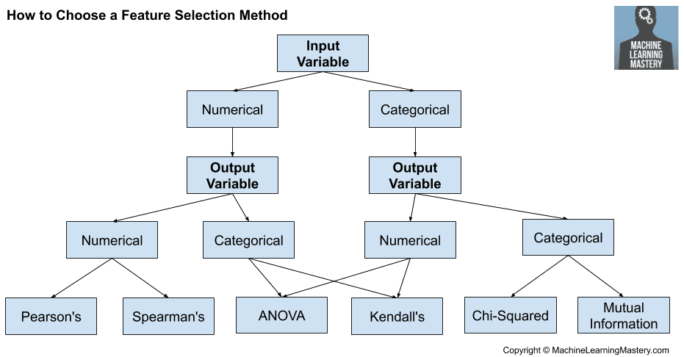

# Imbalance Data Techniques

# Ensembled Techniques

**Ensembled Methods (boosting algorithm):**

The accuracy and reliability of the model can be boosted in two ways. One way is by working on feature engineering and other way is just apply ensembled methods.

Ensemble methods are the combination of several machine learning techniques into one predictive model in order to decrease variance (bagging), bias (boosting), or improve predictions (stacking)

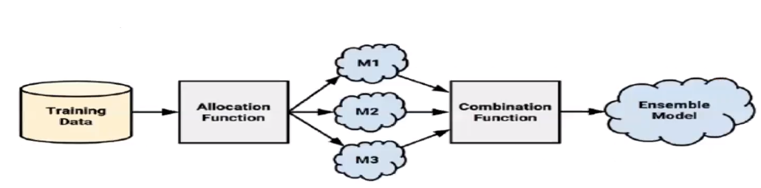

With the training data, allocation function takes responsibility of dividing and supplying the data to different models. Based on this we will build multiple algorithms (different models). Once we build the different models, output of these models would be sent to combining function to combine the output then will get the ensemble model.

Bagging and boosting are the popular ensembled methods.

**Bagging:** It is also called as bootstrap aggregating.

Bootstrapping is a type of resampling where large numbers of smaller samples of the same size are repeatedly drawn, with replacement, from a single original sample.

For example, let’s say your sample was made up of ten numbers: 49, 34, 21, 18, 10, 8, 6, 5, 2, 1. You randomly draw three numbers 5, 1, and 49. You then replace those numbers into the sample and draw three numbers again.

We will build the model 1 and will get the accuracy like that build multiple models with different sets of training and test, then at the end average the accuracy for the model. For classification predictions, we will send the feature (x) values to all the models, from them consider which class got the greater number of times, that class would be the predicted y value. For regression predictions, we will send the feature (x) values to all the models, then the average results of all the models, that would be predicted value of y

**Boosting:** It is also called as AdaBoost. It attempts to create a strong classifier from several weak classifiers.

Initially each data point has weights. If we have 10 data points, then each data point weight would be computed with the formulae 1/n 🡪 will be 1/10. We will build the model1, assume as accuracy of the model is 80%, means this model misclassified 20% of the observations. These 20% of the misclassified records of model1, will be sent to model2 along with some observations from main dataset. Model2 more focus on those 20% and learn the patters to create the model. More focus means those misclassified data points reappear multiple times(duplicated) in Model2 From the Model2 misclassified observations sent to next model like that these processes go on until “n” number of models.

Each model mistakes sent to subsequent model and that subsequent model would focus on the prior model mistakes and tries to learn patterns of those by focusing more on those mistakes of the predecessor model.

Model learns adaptively means on the go model will learn.

**Stacking:** Stacking mainly differ from bagging and boosting on two points. First stacking often considers heterogeneous weak learners (different learning algorithms are combined) whereas bagging and boosting consider mainly homogeneous weak learners. Second, stacking learns to combine the base models using a meta-model whereas bagging and boosting combine weak learners following deterministic algorithms.

As we already mentioned, the idea of stacking is to learn several different weak learners and combine them by training a meta-model to output predictions based on the multiple predictions returned by these weak models.

# Validation Techniques

Before model creation we will apply cross validation

Leave one out cross validation(LooCV): if we have 1000 records, it consider first data point as test and remaining will be in training, based on this model will train on this particular data and tested on one(first data point) single data. Similarly, in the next experiment the next data point (second data point) will be your test and remaining will be training data again same process will be continued 1000 times. If we want to cover every data point, must run 1000 times.

Disadvantages:

* Run many iterations
* Lead to low bias (For the training dataset you get better result, when you get new data in the production, then the accuracy goes down)

K-Fold Cross Validation:

In this if your dataset is 1000, if we select k value that is 5, means it has 5 experiments. For each experiment it will decide based on k value how many data points will be there (1000/5 = 200) in the test data. In the first experiment first 200 will be the test data and the remaining will be the training data. The first experiment model will train on 800 dataset and will be tested on 200 datasets then will get our accuracy 1. In the second experiment the next 200 records will be your test data and remaining will be training data then model will be trained with 800 training dataset and will be tested on 200 datasets then will get our accuracy 2. Similarly, will do for the remaining 3 experiments then mean of 5 experiments accuracy then that could be the accuracy of the model.

Disadvantages:

* In my test data or training data, there is the possibility of one class (as in binary classification) of the data. If the data is imbalanced, the model may not give accuracy with the new data.

Stratified Cross Validation:

Everything will be similar like K-Fold cross validation but whenever we select the test data or training data, it is making sure that the number of records will be distribution in good proportion of the whole dataset so that your model will give good accuracy.

# Decision Tree

**Decision Tree:** In decision tree algorithm the data is continuously split according to a certain parameter. The tree can be explained by two entities, namely decision nodes and leave nodes. The leave nodes are the decisions or the final outcomes. And the decision nodes are where the data is split.

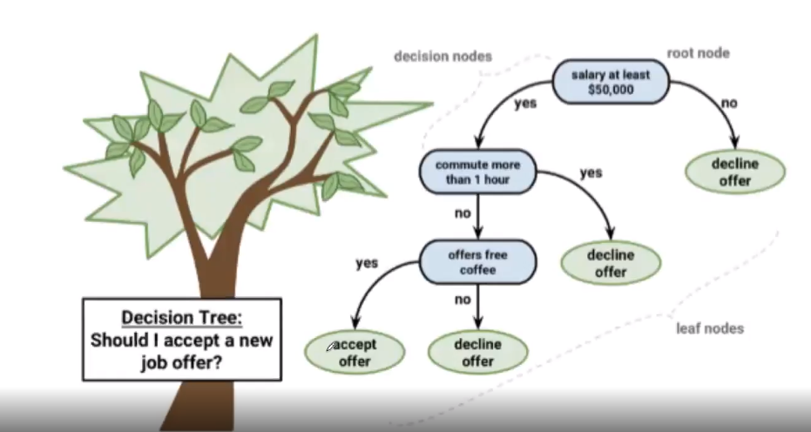

Parameters that we have collected/used for building the model, same parameters should be there for the testing/predicting new records.

Decision Trees are built using recursive partitioning. Recursive partitioning means recursively creates new branches (decision nodes). This approach also commonly known as divide and conquer because it split the data into subsets again those subsets split into further smaller subsets with the moto of creating pure regions. At the end the data in leaf nodes will be in pure regions.

**C5.0 Decision Tree:**

Entropy:

Entropy is measured in bits

If there are two possible classes, entropy value can range from 0 to 1

For n classes entropy range from 0 to log2(n)

If your dataset has equal proportion of both classes (example if we have 100 data points, in that 50 are Yes and 50 are No), then the entropy value for that dataset is 1 that means highest entropy. In the dataset if we have only single class then entropy is 0. This entropy we would used to find the information gain of a feature. If the information gain is more, then that feature is good and if the information gain is low, then that feature is not that important.

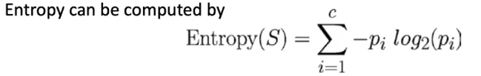

c is number of classes

p is proportion of data points

Solve the following problem

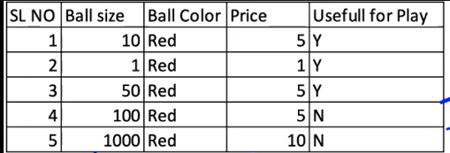

Expanding the above entropy formula:

E = - + (-

🡪 proportion of Y in the above data set that is 3/5 🡪 0.6

🡪 proportion of N in the above data set that is 2/5 🡪 0.4

E = - 0.6 $\log_{2}(0.6)$* + (– 0.4 $\log_{2}(0.4))$

*

E = -0.6 * -0.737 + (-0.4*-1.32)

E = 0.44 + (0.52)

E = 0.97

${Entropy}_{B}$ = 0.97

Information Gain (IG) = -

🡪 Entropy Before split

🡪 Entropy After split

First split: Split the Ball Size with <= 50 and > 50

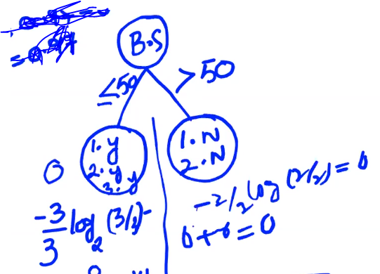

Here we will get ${Entropy}_{A}$ = 0

Information Gain (IG) = 0.97 – 0

I.G = 0.97

Second split: Split the Ball Size with <= 10 and > 10

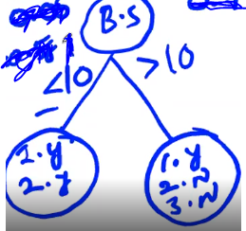

🡪 proportion of Y in the above data set that is 1/3 🡪 0.33

🡪 proportion of N in the above data set that is 2/3 🡪 0.67

E = - 0.33 $\log_{2}(0.33)$* – 0.67 $\log_{2}(0.67)$

*

E = -0.33 * -1.56 -0.67*-0.58

E = 0.53 + (0.38)

E = 0.91

${Entropy}_{A}$ = 0.91

Information Gain (IG) = ${Entropy}_{B}$- ${Entropy}_{A}$

Information Gain (IG) = 0.97 – 0.91

I.G. = 0.06

With the first split we got IG 0.97 and in the second split got 0.06. Always consider highest IG value ie 0.97 split is the correct decision.

Pruning the Decision Tree:

A decision tree can continuous to grow forever by splitting features and dividing the data into smaller and smaller partitions until each example is perfectly classified or *the algorithm runs out of features to split on*. However, if the tree grows overly large, many of the decisions it makes will be overly specific and the model will be overfitted to the training data. The process of pruning a decision tree involves reducing its size such that it generalizes better to unseen data.

If we have 800 features, we are not going to consider all the features to build the decision tree. We will keep only those features in tree which are important in determining “y” class. For those Information Gain value high, we will keep those features.

We determine the root node based on IG, calculate IG for each node and which every feature IG gives highest value that feature becomes root node.

We calculate IG, to find whether the feature is important or not.

“y” variable always exists in leaf notes

To calculate entropy before split on root node, calculate the entropy based on class variable value. In the above example, class variable is “useful for play”. The values in that target feature is y or n.

E = - + (-

🡪 proportion of Y in the above data set that is 3/5 🡪 0.6

🡪 proportion of N in the above data set that is 2/5 🡪 0.4

E = - 0.6 $\log_{2}(0.6)$* + (– 0.4 $\log_{2}(0.4))$

*

E = -0.6 * -0.737 + (-0.4*-1.32)

E = 0.44 + (0.52)

E = 0.97

${Entropy}_{B}$ = 0.97

In which split we get the highest IG. We considered that features and condition is the root node split or decision node split.

# Random Forest Classifier and Regressor

Random forest works based on bagging technique. Internally it creates multiple decision trees (models) by repeatedly drawing large numbers of smaller samples of the same size with replacement. We will be taking some number of rows and columns giving to Decision Tree 1 (Model 1) and similarly it gives to multiple Decision Trees (Models) with replacement. Replacement means some of the rows and columns may repeat in the subsequent models. Now the individual Decision trees will be trained on the given data and will be able to give the accuracy or predictions by aggregating the results of all individual decision trees. For example, in the classification problem Decision Tree1 gives prediction value as 1, Decision Tree2 gives prediction value as 1, Decision Tree3 gives prediction value as 0 and Decision Tree4 gives prediction value as 1. It aggregates the results by majority votes and return the final predicted value as 1.

In general, decision tree creates the model completely until its depth (leaf nodes). Because of this the model properly trained my training data with 0 or less training error that means Low Bias. But with the test data, likely to give larger amount of errors that means high variance. Whenever we create the decision tree completely until its depth leads to be overfitting model. When it comes to Random forest, it aggregates the output of all the decision trees hence it will be low variance as well and become generalized (good) model. Here we are not depending on output of an individual decision tree hence it convert the high variance of individual output to low variance. Even though whenever we change the test data, but still gives low variance.

For Classifier problems, it gives the prediction based on majority of votes. For regressor problems, it calculates the Mean or Median from the individual decision tree results.

By using Hyperparameter we can define how many decision trees you want to use.

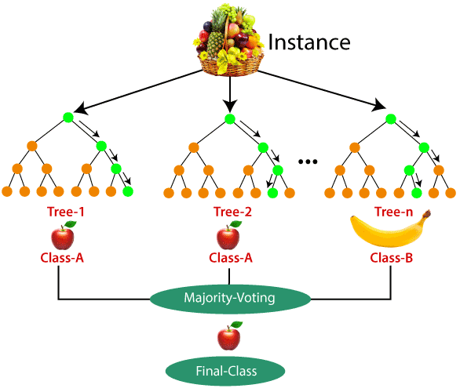

Gini vs entropy

# KNN (K Nearest Neighbor)

# Naïve Bayes:

Joint probability: Joint probabilities are when two events occurs at same time

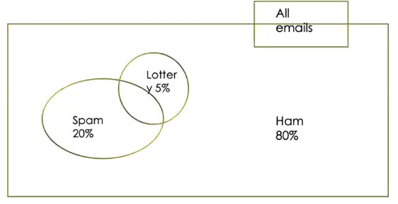

In the above example the probability that incoming mail would be Lottery and Spam is called the joint probability.

If two events are totally unrelated, they are called independent events. In the above example both Lottery and Spam are totally unrelated hence called as independent events.

Compute the joint probability (occurring both independent events together) of Lottery (5% means 0.05) and Spam (20% means 0.20).

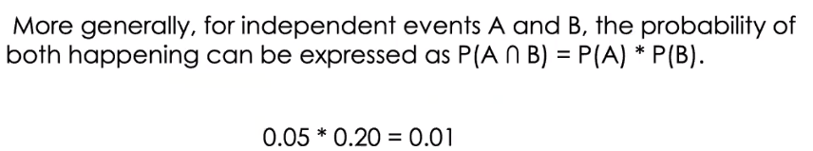

**Bayes Rule (Bayesian Theorem):**

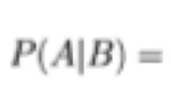 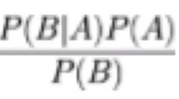

 🡺 Means Probability of A given B

🡺 Means Probability of B given A * Probability of A / Probability of B

English version of Bayes Rule is

Bayesian Theorem says that you can revisit or change your earlier probability with new information.

For example: In the morning estimated their could be the probability of rain(R) tomorrow morning is 0.4. In the evening wheather forcaste announced that massive cyclone(C) is going to hit tonight. Initial probability will change with the new information from 0.4 to 0.9. Based on new information provided by other event(massive cyclone), you are going to revist or change eariler probability.

P(R|C) = $\frac{P(C|R)P\left(R\right)}{P(C)}$

P(R|C) 🡺 Probability of Rain given that their could be Cyclone (probability of Rain revisited based on Cyclone)

P(C|R) 🡺 In the past, when Cyclone hitted what was the probability of the Rain.

P(R) 🡺 In the past, howmany times it was Rained.

P(C) 🡺 In the past, howmany times it was Cyclone.

We can apply Bayes Theorem in Machine Learning with the following interpretation.

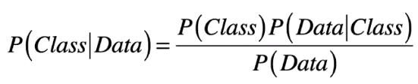

Class is Y Variable

Data is X Variables

Probability of Y after seeing (event given) X Variables. That means for classification problem what is the Y value (either 0 or 1) after seeing X variable values.

Probability of Y value proportion.

Probability of X variable values given the Y value. How many such situations you have seen for this kind of data that belongs to this class.

Probability of X variable values.

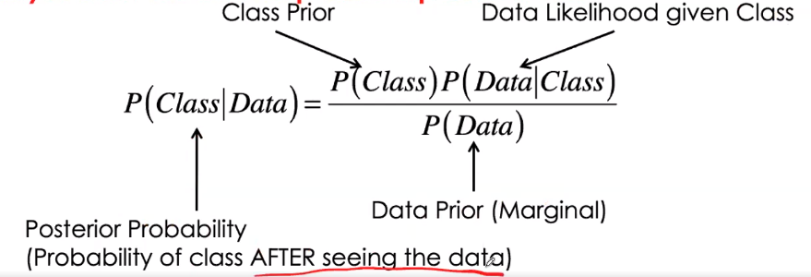

Conditional Independent:



Probability of Fever and Bodyache occurring together when Viral Infection already occurred (happened).

Probability of Fever given Viral Infection

Probability of Bodyache given Viral Infection

This is how we found of joint probability causing with third event

Conditional Independent is nothing but joint probability causing when third event already occurred.

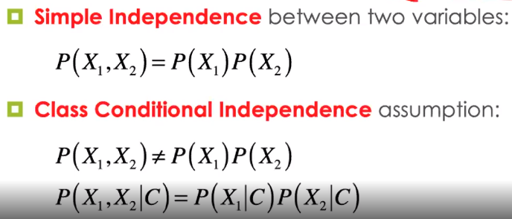

Naïve bayes Classifier: Naïve means basic

It works based on conditional independence.

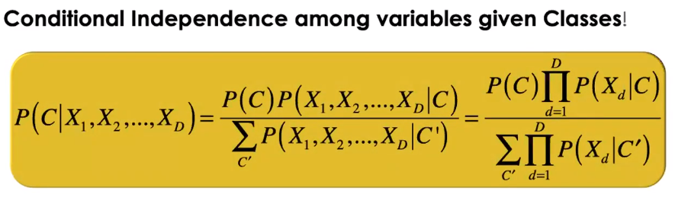

# Support Vector Machine:

It is useful in solving regression and classification problem. As in the classification problem we can linearly separate two class points with hyperplane (straight line). After creating hyperplane, also creates two margin lines which are parallel to hyperplane. These two margin lines will be having some distance, so that it will be easily separable both the classification datapoints. In these two marginal lines, one is marginal line (positive hyperplane) passing through one of the nearest positive point of the negative points and other marginal line (negative hyperplane) is passing through one of the nearest negative point of the positive points. The datapoints which are touching the negative hyperplane and positive hyperplane called as support vectors. The distance between positive hyperplane and negative hyperplane is called Marginal Distance. In SVM, our main aim should be the maximize the Marginal Distance. Based on maximum marginal distance, select best hyperplane.

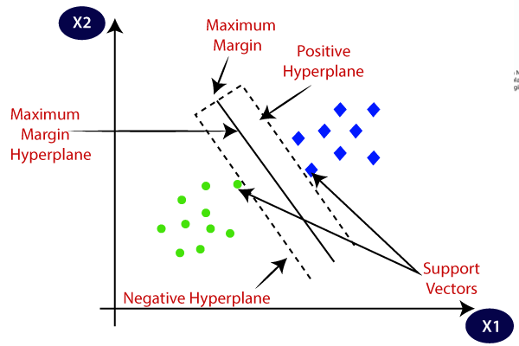

In the above the data was linearly separable data. But if the data is in nonlinear, we will apply Kernel trick to convert nonlinear data into quite linear data.

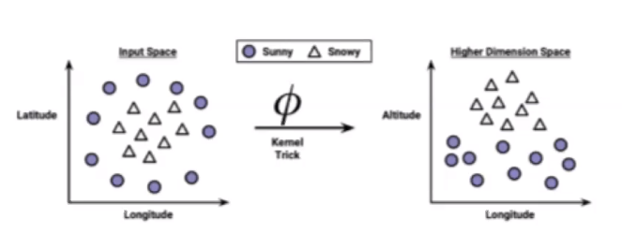

Kernel Trick: It converts the lower dimension data into higher dimension data. In the above example we have 2 dimensions that is Longitude and Latitude, it creates one more dimension (can also create many more dimensions) that is Altitude then pull one class datapoints towards newly created dimension and the remaining class dimensions will be on previous dimensions itself. With this new dimension we can linearly separate the datapoints.

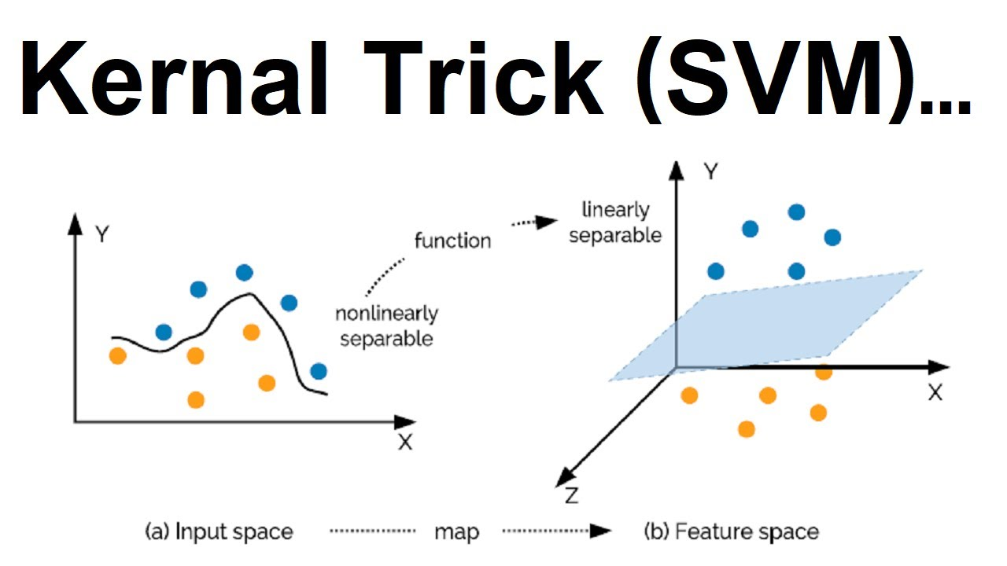

# XgBoost (eXtreme gradient Boosting)

Boosting is noting but sequential learning means model will trained one after another then combine the output to give final result.

Gradient Boosting: <https://www.youtube.com/watch?v=j034-r3O2Cg>

<https://www.youtube.com/watch?v=jxuNLH5dXCs>

Step 1: To compute the Predicted Value (PV1) take the average of Y variable values in regression.

Step 2: Compute residuals/errors/pseudo residuals by subtracting Actual Value from Predicated value (Predicated Value – Actual Value) consider this as R1

Step 3: Construct Decision Tree Model (Residual Model1) with input variables and output variable as Residuals1 (Step 2 output), will get the leaf node values and consider this as Residuals2.

Step 4: Compute new Predicted Value (PV2) by multiplying the learning rate (which will be between 0 to 1 default is 0.1) with Residual2 Value then add the PV1.

Step 5: Compute Residuals(R3) by subtracting Actual Value from Predicated Value2 (PV2 – AV).

Step 6: Construct Decision Tree Model (Residual Model2) with input variables and output variable as Residuals3, will get the leaf node values and consider this as Residuals4.

Step 7: Compute new Predicted Value (PV3) by multiplying the learning rate (which will be between 0 to 1 default is 0.1) with Residual4 Value then add the PV2.

Step 8: Repeat this from Step4 until the residuals closer to Zero.

Ridge and Lasso regression are regularization hyper tuning techniques.

Lasso Regression (L1):

+ *|Slope|

The main aim of Lasso Regression is to select the features and reducing overfitting. If the slop value of the individual feature is closes to Zero, those features will be removed automatically. In this the slop can be zero based on this will remove the features.

Ridge Regression (L2):

+ *

Steep means one unit of X variable increases there is the huge movement of Y value(slop) increases. Steep slop means high slop on best fit line.

In the training data if the residuals are zero, it leads to overfitting test data.

$α$ value greater than or equal to Zero ( $α$ >= 0). If the $α$ value increases the slope value will be decreased and in the training data if the residuals increases, then Slop will be decreased. Once you replace the actual values in $\sum_{i=1}^{n}{(y-}\hat{y})$ + $α$ $({Slope)}^{2}$* formula will get the sum of residual value. As per Ridge Regression, consider the best fit line based on the minimum sum of the residual value. With Ridge Regression generates generalization model with less variance. In this Slop is near to Zero but not exactly zero.

The main aim of Ridge Regression is to reducing overfitting.

Steps in XGBoost:

1. Initialize the prediction value. Prediction value can be anything by default prediction value is 0.5 regardless whether using regression or classification

# Imbalance Dataset

Under sampling

Over sampling

SMOTE

# Loss function

# Data Leakage

# Bias, Variance, Overfitting and Underfitting

Bias: Bias means the error of the training dataset that means the distance between the best fit line and actual training data points.

Variance: Variance means the error of the test dataset that means the distance between the best file line and test data points.

Underfitting Model: As we create the model based on the training dataset, if the error is very high even in the training dataset, that model called as underfitting. In the training data accuracy is low and test data accuracy also very low. This model has high bias and high variance.

Example: Training dataset error is 25% and test dataset error is 26%

Overfitting Model: As we create the model based on the training dataset, the best fit line satisfies the all the data points and the error is very low in training dataset but when comes to test dataset again the error rate will be high, that model called as overfitting. In the training data accuracy is very high and test data accuracy is very low. This model has low bias and high variance. Decision tree is the example for overfitting because by default it creates branches until to its depth that is it creates the decision nodes until to get leaf nodes (pure regions). To overcome this problem, use decision pruning or other hyper parameters by defining the depth of the decision tree.

Example: Training dataset error is 0% and test dataset error is 20%

Generalized (Ideal) Model: As we create the model based on the training dataset, if the error is low in the training dataset and test dataset, that model called as most generalized model or most suitable model to solve problem or best fit model. This model has low bias and low variance. Random forest is the example for generalized model because we use multiple decision trees in parallel. For each decision tree the model is low bias and high variance but in random forest we aggregate (average accuracy) all the decision trees then it becomes low bias and low variance. In general, random forest follows bootstrap aggression. In Bootstrap aggression, gave the partial records (with replacing the datapoints) from dataset to different multiple models.

Example: Training dataset error is lesser than 10% and test dataset error is lesser than 10%

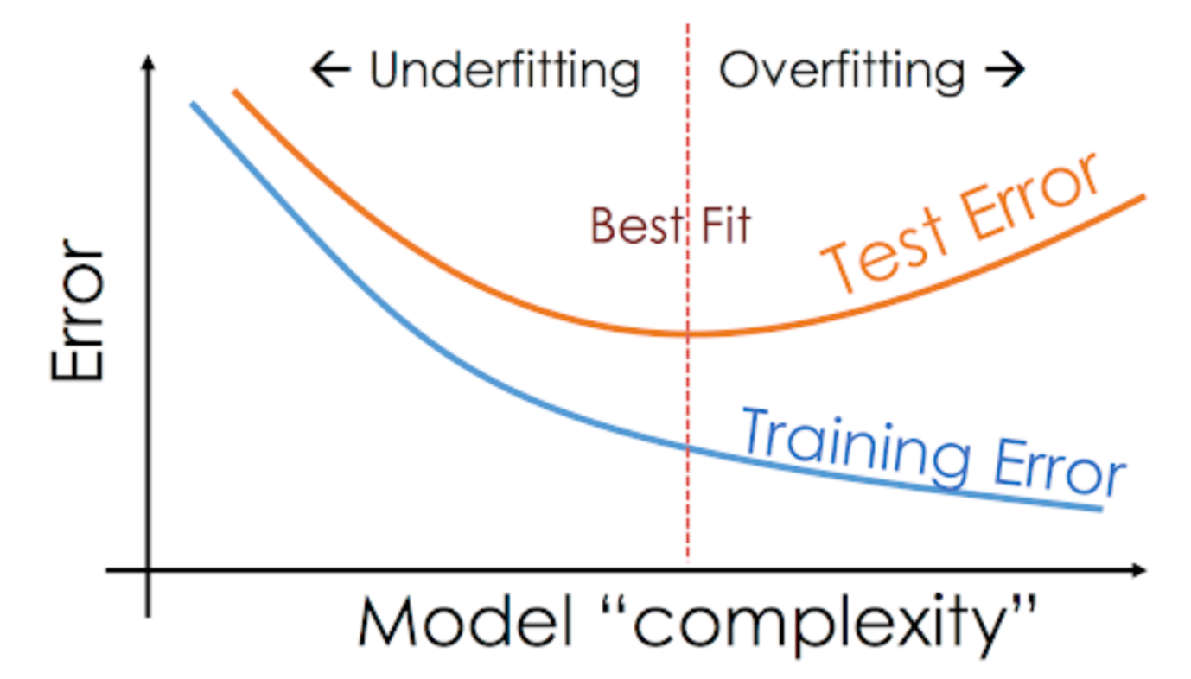

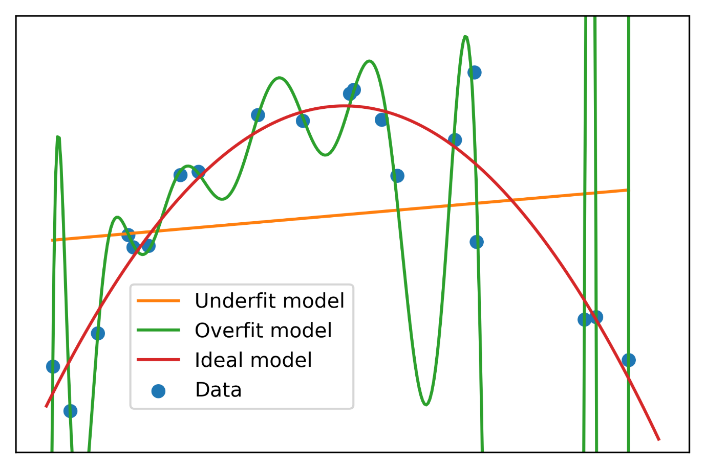

# ANN (Artificial Neural Network):

An ANN models the relationship (find the function) between a set of input signals and an output signal using a methodology similar kind of how our biological brain works that means when someone speaking, some signals are firing from brain and those signals are processed that is how other person can understand what you are speaking. When you speaking there are some neurons are firing signals and other neurons are processing what you are speaking.

that means based on input variables ANN finds the appropriate function to get output variable.

# Time Series

# Natural Language Processing

# Text Mining

# Clustering

# K Mean

# PCA (Principal Component Analysis)

# Association Rules

# Recommendation Engine

<https://www.youtube.com/watch?v=2G7lr_7qqkc>

Entropy: Entropy helps us to measures the purity of split.

Information Gain: This helps to split/construct the decision tree. The higher the information gain that specific way of splitting the decision tree will be taken off.

Euclidean and Manhattan Distances:

Euclidean distance and Manhattan Distances are the techniques to calculate distance between 2 datapoints. For example, if we have 2 features in the dataset and calculate the distance between 2 datapoints

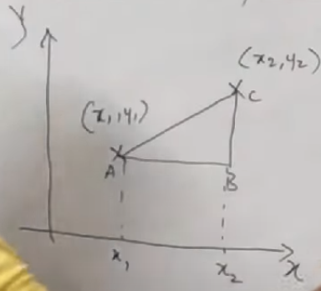

Euclidean distance Formula:

Distance between x and y = $\sqrt{{(x2-x1)}^{2} + {(y2=y1)}^{2}}$

Manhattan distance Formula:

Distance between x and y = |x2-x1| + |y2-y1|

|x2-x1| 🡪 means modulus of x2 – x1. If the value is in negative, consider it as always positive number only.

Recursive Feature Elimination:

RFE works by recursively removing the features and building a model on those attributes that remain.

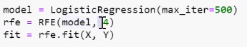

In the above model is the name of algorithm and 4 is the number of features to be required.

In the above example we are applying RFE in conjunction with Logistic Regression.